**LGP-B3149(4931)-40D**

**SFP BIDI 1.25Gb/s TX1310nmFP/RX1490nm(TX1490nmDFB/RX1310nm) 40Dkm DDM**

**PRODUCT FEATURES**

* 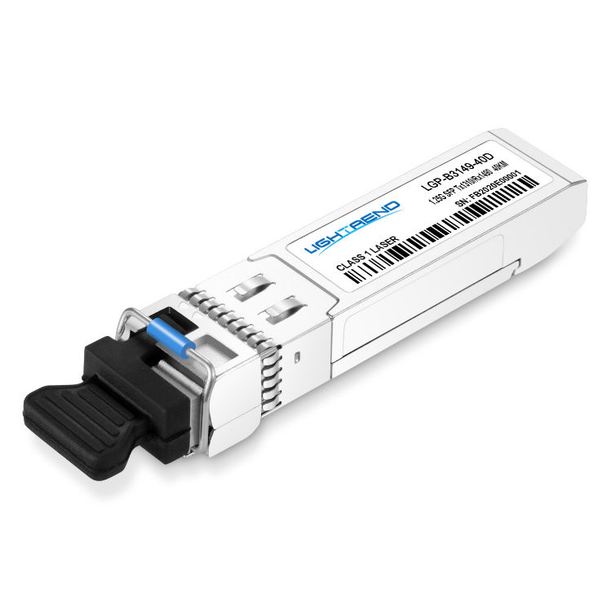Up to 1.25Gb/s data links
* 1310nm FP laser transmitter and

PIN/TIA receiver for LGP-B3149-40D

* 1490nm DFB laser transmitter and

PIN/TIA receiver for LGP-B4931-40D

* Up to 40Dkm on 9/125µm SMF
* Hot-pluggable SFP footprint
* BIDI LC/UPC type pluggable optical interface
* Low power dissipation
* Metal enclosure, for lower EMI
* RoHS compliant and lead-free
* Support Digital Diagnostic Monitor interface
* Single +3.3V power supply
* Compliant with SFF-8472
* Case operating temperature

Commercial: 0°C to +70°C

**APPLICATIONS**

**Compliance**

* SFP MSA
* SFF-8472
* IEEE802.3z
* RoHS
* Switch to Switch Interface
* Fast Ethernet
* Switched Backplane Applications
* Router/Server Interface
* Other Optical Links

**PRODUCT DESCRIPTION**

LGP-B3149(4931)-40D Small Form Factor Pluggable (SFP) transceivers are compatible with the Small Form Factor Pluggable Multi-Sourcing Agreement (MSA). The transceiver consists of five sections: the LD driver, the limiting amplifier, the digital diagnostic monitor, the 1310nm FP laser (the 1490nm DFB laser)and the PIN/TIA .The module data link up to 40Dkm in 9/125um Single-mode fiber.

This transceiver meets the Small Form Pluggable (SFP) industry standard package utilizing an integral LC-Bi-directional optical interface connector. An enhanced Digital Diagnostic Monitoring Interface compliant with SFF-8472 has been incorporated into the transceiver. It allows real time access to the transceiver operating parameters such as transceiver temperature, laser bias current, transmitted optical power, received optical power and transceiver supply voltage by reading a built-in memory with I2C interface.

The optical output can be disabled by a LVTTL logic high-level input of Tx Disable, and the system also can disable the module via I2C. Tx Fault is provided to indicate that degradation of the laser. Loss of signal (LOS) output is provided to indicate the loss of an input optical signal of receiver or the link status with partner. The system can also get the LOS (or Link)/Disable/Fault information via I2C register access.

**Ordering information**

|  |  |  |  |  |  |  |  |
| --- | --- | --- | --- | --- | --- | --- | --- |
| **Package** | **Product part NO.** | **Data Rate** **(Mbps)** | **Media** | **Wavelength** **(nm)** | **Transmission** **Distance(km)** | **Temperature Range（℃）** | |
| SFP | LGP-B3149(4931)-40D | 1250 | Single-mode fiber | 1310T/1490R  (1490T/1310R) | 40 | 0~70 | Commercial |

1. **Pin Diagram**

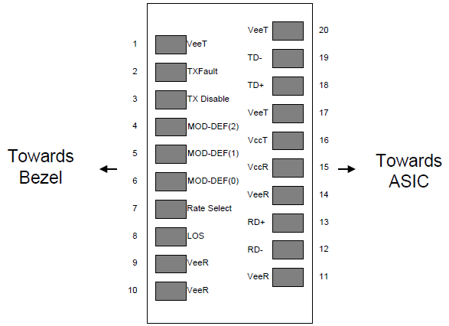

Pin out of Connector Block on Host Board

1. **Pin Descriptions**

|  |  |  |  |
| --- | --- | --- | --- |
| **Pin** | **Symbol** | **Name/Description** | **Ref.** |
| 1 | VEET | Transmitter Ground (Common with Receiver Ground) | 1 |
| 2 | TFAULT | Transmitter Fault. Open Drain. Logic “0” indicates normal operation. | 2 |
| 3 | TDIS | Transmitter Disable. Laser output disabled on high or open. | 3 |
| 4 | MOD_DEF(2) | Module Definition 2. Data line for Serial ID. | 4 |
| 5 | MOD_DEF(1) | Module Definition 1. Clock line for Serial ID. | 4 |
| 6 | MOD_DEF(0) | Module Definition 0. Grounded within the module. | 4 |
| 7 | Rate Select | No connection required. |  |
| 8 | LOS | Loss of Signal indication. Open Drain. Logic “0” indicates normal operation. | 5 |
| 9 | VEER | Receiver Ground (Common with Transmitter Ground) | 1 |
| 10 | VEER | Receiver Ground (Common with Transmitter Ground) | 1 |
| 11 | VEER | Receiver Ground (Common with Transmitter Ground) | 1 |
| 12 | RD- | Receiver Inverted DATA out(CML). AC Coupled |  |
| 13 | RD+ | Receiver Non-inverted DATA out(CML). AC Coupled |  |
| 14 | VEER | Receiver Ground (Common with Transmitter Ground) | 1 |
| 15 | VCCR | Receiver Power Supply |  |
| 16 | VCCT | Transmitter Power Supply |  |
| 17 | VEET | Transmitter Ground (Common with Receiver Ground) | 1 |
| 18 | TD+ | Transmitter Non-Inverted DATA in. AC Coupled. |  |
| 19 | TD- | Transmitter Inverted DATA in. AC Coupled. |  |
| 20 | VEET | Transmitter Ground (Common with Receiver Ground) | 1 |

Notes:

1. Circuit ground is internally isolated from chassis ground.

2. TX Fault is an open drain output, which should be pulled up with 4.7K – 10KΩ resistor on the host board. Pull up voltage between 2.0V to VccT/R+0.3V. When high, output indicates a laser fault of some kind. Low indicates normal operation. In the low state, the output will be pulled to < 0.8V. When sensing an improper power level in the laser driver, the SFP sets this signal high and turns off the laser. TX-FAULT can be reset with the TX-DISABLE line. The signal is in LVTTL level.

3. TX disable is an input that is used to shut down the transmitter optical output. It is pulled up within the module with 4.7K – 10KΩ resistor. Its states are: Low (0 – 0.8V): Transmitter on; (>0.8, < 2.0V): Undefined; High (2.0V to VccT/R+0.3V): Transmitter Disabled; Open: Transmitter Disabled. The TX-DISABLE signal is high (LVTTL logic “1”) to turn off the laser output. The laser will turn on when TX-DISABLE is low (LVTTL logic “0”).

4. Should be pulled up with 4.7K - 10KΩ on host board to a voltage between 2.0V to VccT/R+0.3V. MOD_DEF (0) pulls line low to indicate module is plugged in.

5. LOS (Loss of Signal) is an open collector/drain output, which should be pulled up with 4.7K – 10KΩ resistor. Pull up voltage between 2.0V to VccT/R+0.3V. When high, this output indicates the received optical power is below the worst-case receiver sensitivity (as defined by the standard in use). Low indicates normal operation. In the low state, the output will be pulled to < 0.8V.

The RX-LOS is high (LVTTL logic “1”) when there is no incoming light from the companion transceiver. This signal is normally used by the system for the diagnostic purpose. The signal is operated in LVTTL level.

1. **Absolute Maximum Ratings**

|  |  |  |  |  |  |  |
| --- | --- | --- | --- | --- | --- | --- |
| **Parameter** | **Symbol** | **Min.** | **Typ.** | **Max.** | **Unit** | **Ref.** |
| Storage Temperature | TS | -40D |  | 85 | ºC |  |
| Storage Ambient Relative Humidity | HA | 0 |  | 85 | % |  |
| Power Supply Voltage | VCC | -0.5 |  | 4 | V |  |
| Signal Input Voltage |  | -0.3 |  | Vcc+0.3 | V |  |
| Receiver Damage Threshold |  | +3 |  |  | dBm |  |
| Lead Soldering Temperature/Time | TSOLD |  |  | 260/10 | ºC/sec | Note (1) |
| Lead Soldering Temperature/Time | TSOLD |  |  | 360/10 | ºC/sec | Note (2) |

Note (1): Suitable for wave soldering.

Note (2): Only for soldering by iron.

1. **Recommended Operating Conditions**

|  |  |  |  |  |  |  |
| --- | --- | --- | --- | --- | --- | --- |
| **Parameter** | **Symbol** | **Min.** | **Typ.** | **Max.** | **Unit** | **Ref.** |
| Case Operating Temperature | Tcase | 0 |  | 70 | ºC | LGP-B3149(4931)-40D |
| Ambient Humidity | HA | 5 |  | 70 | % | Non-condensing |
| Power Supply Voltage | VCC | 3.13 | 3.3 | 3.47 | V |  |
| Power Supply Current | ICC |  |  | 280 | mA |  |
| Data Rate |  |  | 1250/1250 |  | Mbps | TX Rate/RX Rate |
| Transmission Distance |  |  |  | 40D | km |  |
| Coupled Fiber | Single mode fiber | | | | | 9/125um G.652 |

1. **Specification of Transmitter**

|  |  |  |  |  |  |  |
| --- | --- | --- | --- | --- | --- | --- |
| **Parameter** | **Symbol** | **Min.** | **Typ.** | **Max.** | **Unit** | **Ref.** |
| Average Output Power | POUT | -5 |  | 0 | dBm |  |
| -5 |  | 0 |  |
| Extinction Ratio | ER | 9 |  |  | dB |  |
| Center Wavelength | λC | 1260 | 1310 | 1360 | nm |  |
| 1470 | 1490 | 1510 |  |
| Spectrum Width (RMS) | σ |  |  | 3.5 | nm | FP Laser  (TX:1310nm) |
| Side Mode Suppression Ratio | SMSR | 30 |  |  | dB | DFB Laser  (TX:1490nm) |
| Spectrum Bandwidth(-20dB) | σ |  |  | 1 | nm |
| Transmitter OFF Output Power | POff |  |  | -45 | dBm |  |
| Jitter p-p | tJ |  |  | 0.1 | UI | Note (1) |
| Output Eye Mask | Compliant with IEEE802.3 z (class 1 laser safety) | | | |  | Note (2) |

Note (1): Measure at 2^7-1 NRZ PRBS pattern.

Note (2): Transmitter eye mask definition.

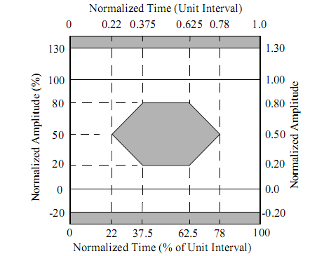

1. **Specification of Receiver**

|  |  |  |  |  |  |  |
| --- | --- | --- | --- | --- | --- | --- |
| **Parameter** | **Symbol** | **Min.** | **Typ.** | **Max.** | **Unit** | **Ref.** |
| Input Optical Wavelength | λIN | 1440D | 1490 | 1540D | nm |  |
| 1290 | 1310 | 1330 |  |
| Receiver Sensitivity | PIN |  |  | -24 | dBm | Note (1) |
| InputSaturation Power (Overload) | PSAT | -3 |  |  | dBm |  |
| Loss of Signal Assert | PA | -45 |  |  | dBm |  |
| Loss of Signal De-assert | PD |  |  | -24.5 | dBm | Note (2) |
| LOS Hysteresis | PD-PA | 0.5 |  | 6 | dB |  |

Note (1): Measured with Light source 1490nm(1310nm), ER=9dB; BER =<10^-12 @PRBS=2^7-1 NRZ

Note (2): When LOS De-asserted, the RX data+/- output is signal output.

1. **Digital Diagnostic Memory Map**

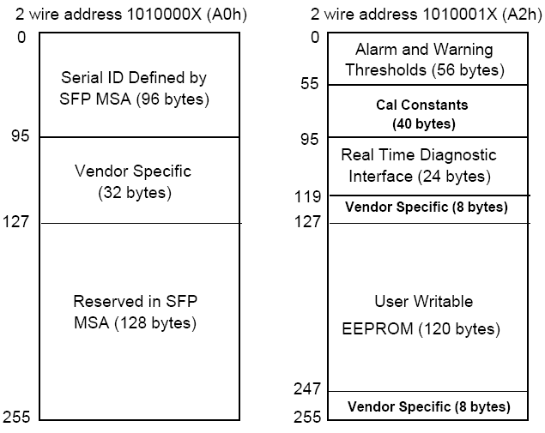

1. **Digital Diagnostic Monitoring Information**

|  |  |  |
| --- | --- | --- |
| **Parameter** | **Unit** | **Accuracy** |
| Case Temperature | ℃ | ±3 |
| Supply Voltage | V | ±3% |
| Tx Bias Current | mA | ±10% |
| Tx Optical Power | dB | ±3 |
| Rx Optical Power | dB | ±3 |

1. **Electrical Interface Characteristics**

|  |  |  |  |  |  |  |
| --- | --- | --- | --- | --- | --- | --- |
| **Parameter** | **Symbol** | **Min.** | **Typ.** | **Max.** | **Unit** | **Ref.** |
| **Transmitter** | | | | | | |
| Total Supply Current | ICC |  |  | A | mA | Note (1) |
| Transmitter Disable Input-High | VDISH | 2 |  | Vcc+0.3 | V | LVTTL |
| Transmitter Disable Input-Low | VDISL | 0 |  | 0.8 | V |
| Transmitter Fault Input-High | VTxFH | 2 |  | Vcc+0.3 | V |
| Transmitter Fault Input-Low | VTxFL | 0 |  | 0.8 | V |
| **Receiver** | | | | | | |
| Total Supply Current | ICC |  |  | B | mA | Note (1) |
| LOS Output Voltage-High | VLOSH | 2 |  | Vcc+0.3 | V | LVTTL |
| LOS Output Voltage-Low | VLOSL | 0 |  | 0.8 | V |

Note (1): A (TX) + B (RX) = 280mA (Not include termination circuit)

1. **Recommend Circuit Schematic**

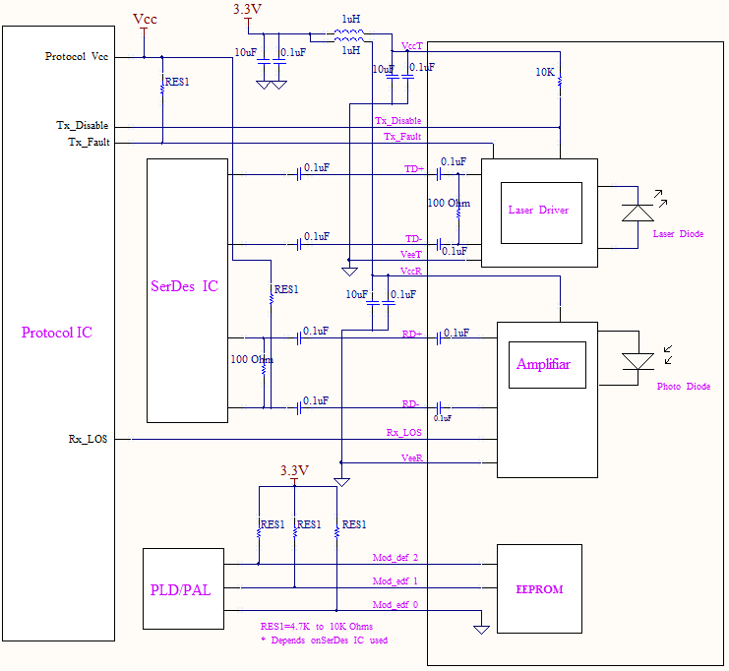

1. **Mechanical Specifications** (Unit: mm)

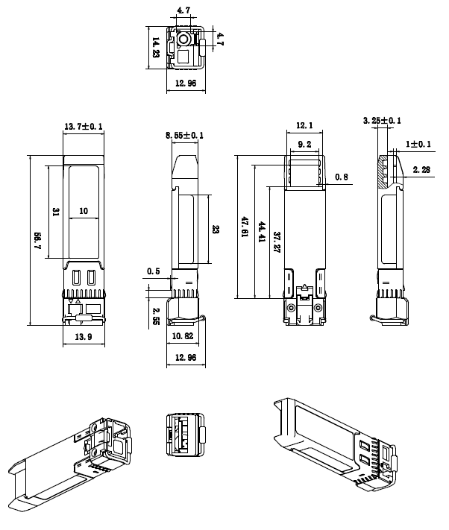

**LGP-B3149(4931)-40D**

1. **Regulatory Compliance**

|  |  |  |
| --- | --- | --- |
| **Feature** | **Reference** | **Performance** |
| EMC | EN61000-3 | Compatible with standards |
| Electrostatic Discharge （ESD） | IEC/EN 61000-4-2 | Compatible with standards |
| Electromagnetic Interference (EMI) | FCC Part 15 Class B EN 55022 Class B (CISPR 22A) | Compatible with standards |
| Laser Eye Safety | FDA 21CFR 1040D.10, 1040D.11 IEC/EN 60825-1 ,EC/EN 60825-2 | Class 1 laser product |
| Component Recognition | IEC/EN 60950 ,L 60950 | Compatible with standards |
| ROHS | 2002/95/EC | Compatible with standards |

**Revision History**

|  |  |  |
| --- | --- | --- |
| **Version No.** | **Date** | **Description** |
| 1.0 | June 24, 2019 | Preliminary datasheet |