LGP-H55-80D
SFP 1.25Gb/s 1550nm Single-mode 80km DDM
PRODUCT FEATURES
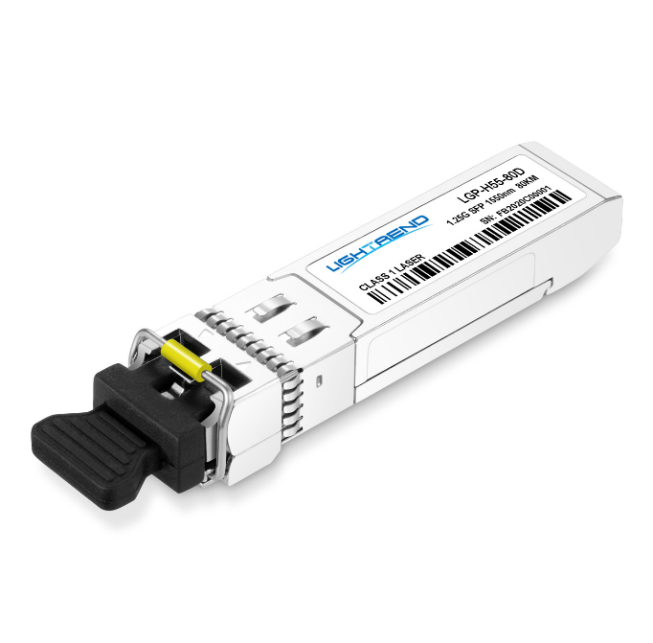
- Up to 1.25Gb/s data links
- 1550nm DFB laser transmitter and PIN/TIA receiver
- Up to 80km on 9/125µm SMF
- Hot-pluggable SFP footprint
- Duplex LC/UPC type pluggable optical interface
- Low power dissipation
- Metal enclosure, for lower EMI
- RoHS compliant and lead-free
- Support Digital Diagnostic Monitor interface
- Single +3.3V power supply
- Compliant with SFF-8472
- Case operating temperature
Commercial: 0°C to +70°C
Compliance
- SFP MSA
- SFF-8472
- IEEE802.3z
- RoHS

APPLICATIONS
- Switch to Switch Interface
- Fast Ethernet
- Switched Backplane Applications
- Router/Server Interface
- Other Optical Links

PRODUCT DESCRIPTION
LGP-H55-80D Small Form Factor Pluggable (SFP) transceivers are compatible with the Small Form Factor Pluggable Multi-Sourcing Agreement (MSA).The transceiver consists offive sections: the LD driver, the limiting amplifier,the digital diagnostic monitor,the 1550nm DFB laserand the PIN/TIA.The module data link up to 80km in 9/125umSingle-mode fiber.
This transceiver meets the Small Form Pluggable (SFP) industry standard package utilizing an integral LC-Duplex optical interface connector. An enhanced Digital Diagnostic Monitoring Interface compliant with SFF-8472 has been incorporated into the transceiver. It allows real time access to the transceiver operating parameters such as transceiver temperature, laser bias current, transmitted optical power, received optical power and transceiver supply voltage by reading a built-in memory with I²C interface.
The optical output can be disabled by a LVTTL logic high-level input of Tx Disable, and the system also candisable the module via I²C. Tx Fault is provided to indicate that degradation of the laser. Loss of signal(LOS) output is provided to indicate the loss of an input optical signal of receiver or the link status withpartner. The system can also get the LOS(or Link)/Disable/Fault information via I²C register access.

Ordering information
Package | Product part NO. | Data Rate(Mbps) | Media | Wavelength(nm) | TransmissionDistance(km) | Temperature Range（℃）
SFP | LGP-H55-80D | 1250 | single-mode fiber | 1550 | 80 | 0~70 | Commercial
- Pin Diagram
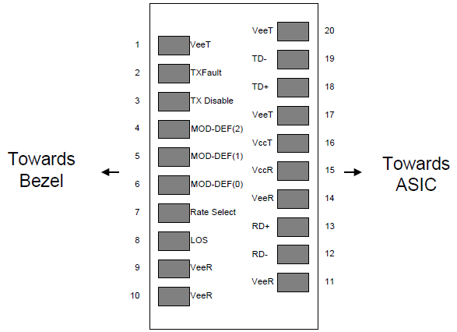
Pinout of Connector Block on Host Board
- Pin Descriptions
Pin | Symbol | Name/Description | Ref.
1 | V_{EET} | Transmitter Ground (Common with Receiver Ground) | 1
2 | T_{FAULT} | Transmitter Fault.Open Drain. Logic “0” indicates normal operation. | 2
3 | T_{DIS} | Transmitter Disable. Laser output disabled on high or open. | 3
4 | MOD_DEF(2) | Module Definition 2. Data line for Serial ID. | 4
5 | MOD_DEF(1) | Module Definition 1. Clock line for Serial ID. | 4
6 | MOD_DEF(0) | Module Definition 0. Grounded within the module. | 4
7 | Rate Select | No connection required.
8 | LOS | Loss of Signal indication. Open Drain. Logic “0” indicates normal operation. | 5
9 | V_{EER} | Receiver Ground (Common with Transmitter Ground) | 1
10 | V_{EER} | Receiver Ground (Common with Transmitter Ground) | 1
11 | V_{EER} | Receiver Ground (Common with Transmitter Ground) | 1
12 | RD- | Receiver Inverted DATA out(CML). AC Coupled
13 | RD+ | Receiver Non-inverted DATA out(CML). AC Coupled
14 | V_{EER} | Receiver Ground (Common with Transmitter Ground) | 1
15 | V_{CCR} | Receiver Power Supply
16 | V_{CCT} | Transmitter Power Supply
17 | V_{EET} | Transmitter Ground (Common with Receiver Ground) | 1
18 | TD+ | Transmitter Non-Inverted DATA in. AC Coupled.
19 | TD- | Transmitter Inverted DATA in. AC Coupled.
20 | V_{EET} | Transmitter Ground (Common with Receiver Ground) | 1
Notes:
1. Circuit ground is internally isolated from chassis ground.
2. TX Fault is an open drain output, which should be pulled up with 4.7K – 10KΩ resistor on the host board. Pull up voltage between 2.0V toVccT/R+0.3V. When high, output indicates a laser fault of some kind. Low indicates normal operation. In the low state, the output will be pulled to < 0.8V.When sensing an improper power level in the laser driver, the SFP sets this signal high and turns off the laser. TX-FAULT can be reset with the TX-DISABLE line. The signal is in LVTTL level.
3. TX disable is an input that is used to shut down the transmitter optical output. It is pulled up within the module with 4.7K – 10KΩ resistor. Its states are: Low (0 – 0.8V): Transmitter on; (>0.8, < 2.0V): Undefined; High (2.0V toVccT/R+0.3V): Transmitter Disabled; Open: Transmitter Disabled. The TX-DISABLE signal is high (LVTTL logic “1”) to turn off the laser output. The laser will turn on when TX-DISABLE is low (LVTTL logic “0”).
4. Should be pulled up with 4.7K - 10KΩon host board to a voltage between 2.0V toVccT/R+0.3V. MOD_DEF(0) pulls line low to indicate module is plugged in.
5. LOS (Loss of Signal) is an open collector/drain output, which should be pulled up with 4.7K – 10KΩresistor. Pull up voltage between 2.0V toVccT/R+0.3V. When high, this output indicates the received optical power is below the worst-case receiver sensitivity (as defined by the standard in use). Low indicates normal operation. In the low state, the output will be pulled to < 0.8V.
The RX-LOS is high (LVTTL logic “1”) when there is no incoming light from the companion transceiver. This signal is normally used by the system for the diagnostic purpose. The signal is operated in LVTTL level.
- Absolute Maximum Ratings
Parameter | Symbol | Min. | Typ. | Max. | Unit | Ref.
Storage Temperature | T_{S} | -40 |  | 85 | ºC
Storage Ambient Relative Humidity | H_{A} | 0 |  | 85 | %
Power Supply Voltage | V_{CC} | -0.5 |  | 4 | V
Signal Input Voltage |  | -0.3 |  | Vcc+0.3 | V
Receiver Damage Threshold |  | +3 |  |  | dBm
Lead Soldering Temperature/Time | TSOLD |  |  | 260/10 | ºC/sec | Note (1)
Lead Soldering Temperature/Time | TSOLD |  |  | 360/10 | ºC/sec | Note (2)
Note (1): Suitable for wave soldering.
Note (2): Only for soldering by iron.
- Recommended Operating Conditions
Parameter | Symbol | Min. | Typ. | Max. | Unit | Ref.
Case Operating Temperature | T_{case} | 0 |  | 70 | ºC | LGP-H55-80D
Ambient Humidity | H_{A} | 5 |  | 70 | % | Non-condensing
Power Supply Voltage | V_{CC} | 3.13 | 3.3 | 3.47 | V
Power Supply Current | I_{CC} |  |  | 280 | mA
Data Rate |  |  | 1250/1250 |  | Mbps | TX Rate/RX Rate
Transmission Distance |  |  |  | 80 | km
Coupled Fiber | Singlemode fiber |  |  |  |  | 9/125um G.652
- Specification of Transmitter
Parameter | Symbol | Min. | Typ. | Max. | Unit | Ref.
Average Output Power | P_{OUT} | 0 |  | +5 | dBm
Extinction Ratio | ER | 9 |  |  | dB
Center Wavelength | λC | 1530 | 1550 | 1570 | nm | LGP-H55-80D
Side Mode Suppression Ratio | SMSR | 30 |  |  | dBm | DFB Laser
Spectrum Bandwidth(-20dB) | σ |  |  | 1 | nm
Transmitter OFF Output Power | POff |  |  | -45 | dBm
Jitter p-p | tJ |  |  | 0.1 | UI | Note (1)
Output Eye Mask | Compliant with IEEE802.3z (class 1 laser safety) |  |  |  |  | Note (2)
Note (1): Measure at 2^7-1 NRZ PRBS pattern.
Note (2): Transmitter eye mask definition.
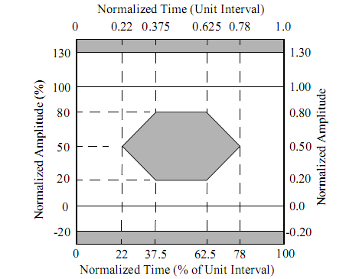
- Specification of Receiver
Parameter | Symbol | Min. | Typ. | Max. | Unit | Ref.
Input Optical Wavelength | λ_{IN} | 1270 |  | 1610 | nm | LGP-H55-80D
Receiver Sensitivity | PIN |  |  | -24 | dBm | Note (1)
InputSaturation Power (Overload) | PSAT | -3 |  |  | dBm
Loss of Signal Assert | PA | -45 |  |  | dBm
Loss of Signal De-assert | PD |  |  | -24.5 | dBm | Note (2)
LOS Hysteresis | PD-PA | 0.5 |  | 6 | dB
Note (1):Measured with Light source 1550nm, ER=9dB; BER =<10^-12 @PRBS=2^7-1 NRZ
Note (2): When LOS De-asserted, the RX data+/- output is signal output.
- Digital Diagnostic Memory Map
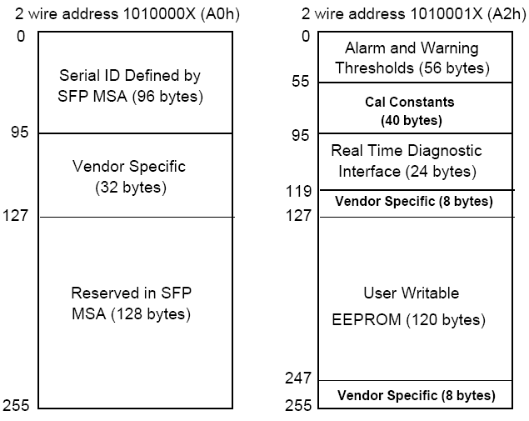
- Digital Diagnostic Monitoring Information
Parameter | Unit | Accuracy
Case Temperature | ℃ | ±3
Supply Voltage | V | ±3%
Tx Bias Current | mA | ±10%
Tx Optical Power | dB | ±3
Rx Optical Power | dB | ±3
- Electrical Interface Characteristics
Parameter | Symbol | Min. | Typ. | Max. | Unit | Ref.
Transmitter
Total Supply Current | ICC |  |  | A | mA | Note (1)
Transmitter Disable Input-High | VDISH | 2 |  | Vcc+0.3 | V | LVTTL
Transmitter Disable Input-Low | VDISL | 0 |  | 0.8 | V
Transmitter Fault Input-High | VTxFH | 2 |  | Vcc+0.3 | V
Transmitter Fault Input-Low | VTxFL | 0 |  | 0.8 | V
Receiver
Total Supply Current | ICC |  |  | B | mA | Note (1)
LOS Output Voltage-High | VLOSH | 2 |  | Vcc+0.3 | V | LVTTL
LOS Output Voltage-Low | VLOSL | 0 |  | 0.8 | V
Note (1): A (TX)+ B (RX) = 280mA (Not include termination circuit)
- Recommend Circuit Schematic
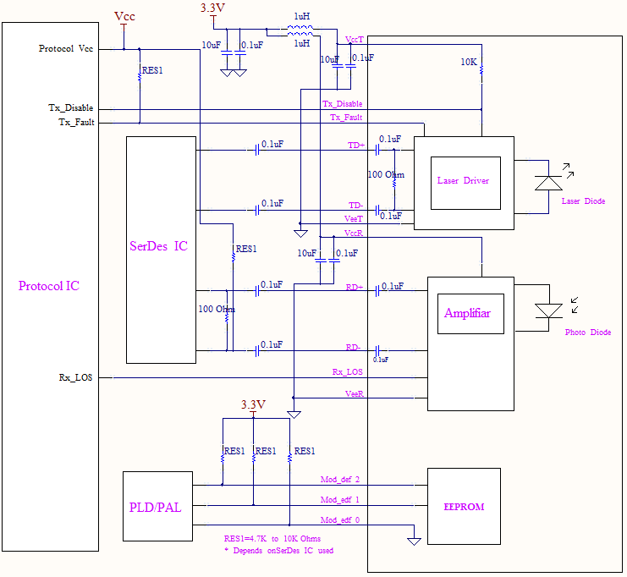
- Mechanical Specifications(Unit: mm)
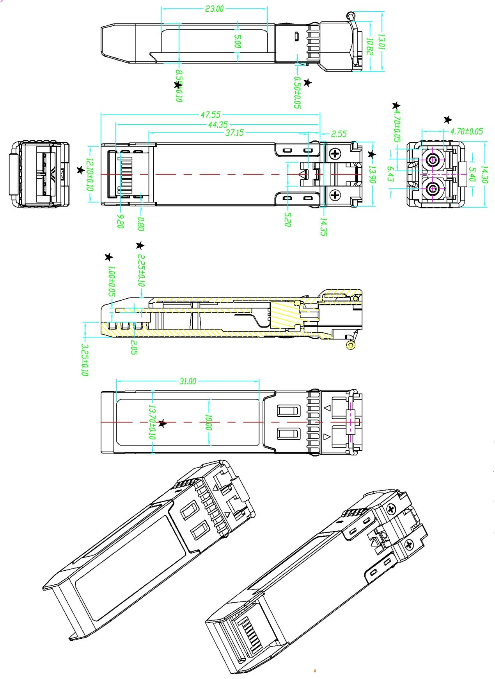
LGP-H55-80D
- Regulatory Compliance
Feature | Reference | Performance
EMC | EN61000-3 | Compatible with standards
Electrostatic Discharge （ESD） | IEC/EN 61000-4-2 | Compatiblewith standards
Electromagnetic Interference (EMI) | FCC Part 15 Class B EN 55022 Class B (CISPR 22A) | Compatible with standards
Laser Eye Safety | FDA 21CFR 1040.10, 1040.11 IEC/EN 60825-1 ,EC/EN 60825-2 | Class 1 laser product
Component Recognition | IEC/EN 60950 ,L 60950 | Compatible with standards
ROHS | 2002/95/EC | Compatible with standards
Revision History
Version No. | Date | Description
1.0 | June 24, 2019 | Preliminary datasheet

