SFP25G-BX2733(3327)-10I
SFP28BiDi25Gb/s TX1270nmDFB/RX1330nm(TX1330nmDFB/RX1270nm)10km DDM Transceiver
PRODUCT FEATURES
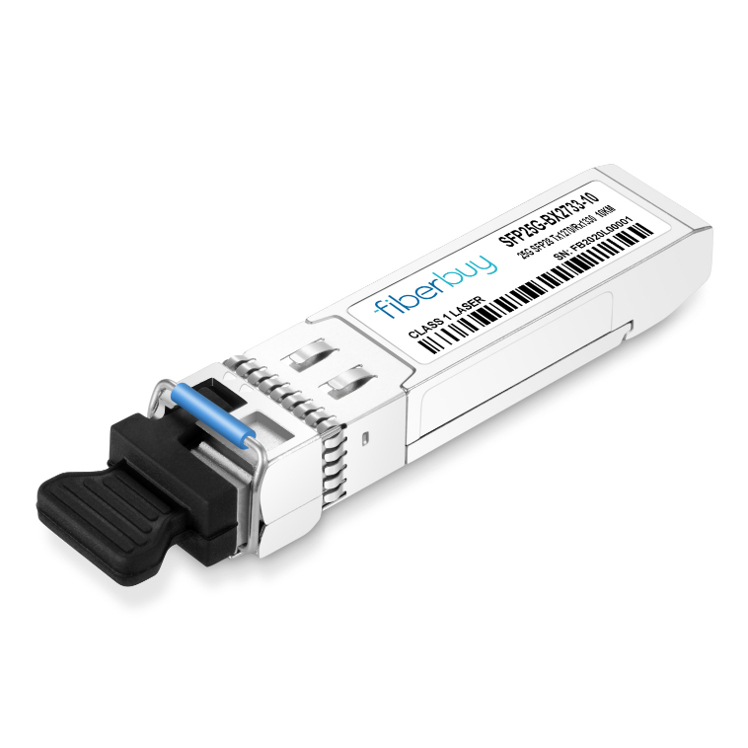
- Up to 25.7813Gbps Data Links
- 1270nm DFB laser transmitter and PIN/TIA receiver
- 1330nm DFB laser transmitter and PIN/TIA receiver
- Maximum link length of 10km on Single Mode Fiber
- Hot-pluggable SFP28 footprint
- Single LC receptacles
- Low power dissipation
- RoHS compliant and lead-free
- Support Digital Diagnostic Monitor interface
- Single +3.3V power supply
- -40°C to +85°C case operating temperature
APPLICATIONS
Compliance
- SFF-8472
- SFF-8402
- SFF-8432
- SFF-8431
- CEI-28G-VSR
- 25GBASE-LR Ethernet
- CPRI

Ordering information
Package | Product part NO. | Distance | Temperature Range
SFP28 | SFP25G-BX2733(3327)-10I | 10km | -40~85℃
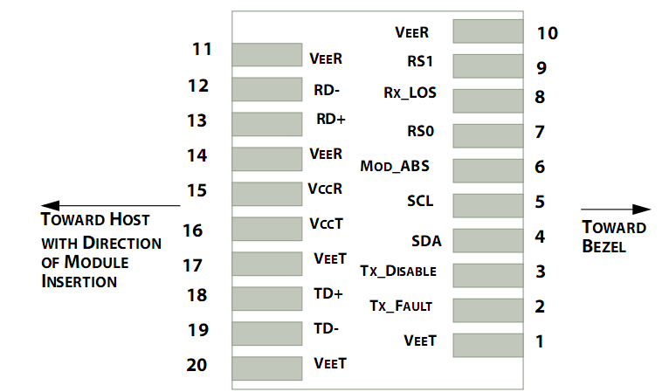
- Pin Diagram
Pinout of Connector Block on Host Board
- Pin Descriptions
Pin | Symbol | Name/Description | Ref.
1 | V_{EET} | Transmitter Ground (Common with Receiver Ground) | 1
2 | T_{FAULT} | Transmitter Fault. | 2
3 | T_{DIS} | Transmitter Disable.Laser output disabled on high or open. | 3
4 | SDA | 2-wire Serial Interface Data Line | 4
5 | SCL | 2-wire Serial Interface Clock Line | 4
6 | MOD_ABS | Module Absent. Grounded within the module | 4
7 | RS0 | No connection required
8 | LOS | Loss of Signal indication.Logic “0” indicates normal operation. | 5
9 | RS1 | No connection required
10 | V_{EER} | Receiver Ground (Common with Transmitter Ground) | 1
11 | V_{EER} | Receiver Ground (Common with Transmitter Ground) | 1
12 | RD- | Receiver Inverted DATA out.AC Coupled
13 | RD+ | Receiver Non-inverted DATA out.AC Coupled
14 | V_{EER} | Receiver Ground(Common with Transmitter Ground) | 1
15 | V_{CCR} | Receiver Power Supply
16 | V_{CCT} | Transmitter Power Supply
17 | V_{EET} | Transmitter Ground(Common with Receiver Ground) | 1
18 | TD+ | Transmitter Non-Inverted DATA in. AC Coupled.
19 | TD- | Transmitter Inverted DATA in. AC Coupled.
20 | V_{EET} | Transmitter Ground(Common with Receiver Ground) | 1
Notes:
1. Circuit ground is internally isolated from chassis ground.
2. TFAULT is an open collector/drain output, which is pulled up with a 4.7kΩ – 10kΩ resistor on the host board, but is grounded inside the SFP+ cable plug.
3. Laser output disabled on TDIS >2.0V or open, enabled on TDIS <0.8V.
4. Should be pulled up with 4.7kΩ – 10kΩ on host board to a voltage between 2.0V and 3.6V. MOD_ABS pull line low to indicate module is plugged in.
5. LOS is open collector output. Should be pulled up with 4.7kΩ – 10kΩ on host board to a voltage between 2.0V and 3.6V. Logic 0 indicates normal operation; logic 1 indicates loss of signal.
- Absolute Maximum Ratings
Parameter | Symbol | Min | Typ | Max | Unit | Ref.
Maximum Supply Voltage | Vcc | -0.5 |  | 3.6 | V
Storage Temperature | TS | -40 |  | 85 | ℃ | 1
Case Operating Temperature | TOP | -40 |  | 85 | ℃
Relative Humidity | RH | 0 |  | 85 | % | 2
Notes:
1.Limited by the fiber cable jacket, not the activeends.
2.Non-condensing.
- Optical Characteristics(TOP = -40°C to 85°C, VCC = 3.3 ± 5% Volts)
Parameter | Symbol | Min. | Typ. | Max. | Unit | Remark
Transmitter
Center Wavelength | λc | 1260 | 1270 | 1280 | nm
 |  | 1320 | 1330 | 1340
Spectral Width | Pm |  |  | 1 | nm
Average Output Power | Pavg | -7 |  | 2 | dBm
Optical Modulation Amplitude (OMA) | Poma | -4 |  | 2.2 | dBm
Extinction Ratio | ER | 3.5 |  |  | dB
Transmitter Dispersion Penalty | TDP |  |  | 2.7 | dB
Relative Intensity Noise | Rin |  |  | -130 | dB/Hz
Optical Return Loss Tolerance | TOL |  |  | 20 | dB
Transmitter OFF Output Power | POff |  |  | -30 | dBm
Transmitter eye mask definition {X1,X2,X3,Y1,Y2,Y3}, 25Gbase_LR |  | {0.31, 0.4, 0.45, 0.34, 0.38, 0.4}
Receiver
Center Wavelength | λc | 1320 | 1330 | 1340 | nm
 |  | 1260 | 1270 | 1280
Receiver Sensitivity, Average Power |  |  |  | -13.3 | dBm
Receiver Sensitivity, OMA |  |  |  | -12 | dBm
Receiver Reflectance | Rfl |  |  | -26 | dBm
Loss of Signal Assert | P_{A} | -30 |  |  | dBm
Loss of Signal De-assert | P_{D} |  |  | -16 | dBm
LOS Hysteresis | P_{D}- P_{A} | 0.5 |  |  | dB
- Electrical Characteristics (TOP = -40°C to 85°C, VCC = 3.3 ± 5% Volts)
Parameter | Symbol | Min | Typ | Max | Unit | Ref.
SupplyVoltage | Vcc | 3.135 | 3.3 | 3.465 | V
SupplyCurrent | Icc |  |  | 300 | mA
Transmitter
Input differential impedance | Rin |  | 100 |  |  | 1
Differential data input swing | Vin,pp | 180 |  | 900 | mV
Transmit Disable Voltage | V_{D} | 2 |  | V_{CC} | V
Transmit Enable Voltage | V_{EN} | Vee |  | Vee+0.8 | V
Receiver
Differential data output swing | Vout,pp | 400 |  | 800 | mV | 2
LOS Fault | V_{LOS_fault} | 2 |  | VccHOST | V | 3
LOS Normal | V_{LOS_norm} | Vee |  | Vee+0.8 | V | 3
Power Supply Noise Tolerance | V_{CCT}/V_{CCR} | Per SFF-8431 Rev 4.1 |  |  | mVpp | 4
Notes:
1.Into 100Ω differential termination.
2.20-80%Measured with Module Compliance Test Board and OMA test pattern. Use of four 1’s and four 0’s in sequence in the PRBS^9 is an acceptable alternative. SFF-8431 Rev 4.1
3. LOS is an open collector output. Should be pulled up with 4.7kΩ – 10kΩ on the host board. Normal operation is logic 0; loss of signal is logic 1. Maximum pull-up voltage is 5.5V.
4. Testing methodology per SFF-8431. Rev 4.1.
- Digital Diagnostic Memory Map
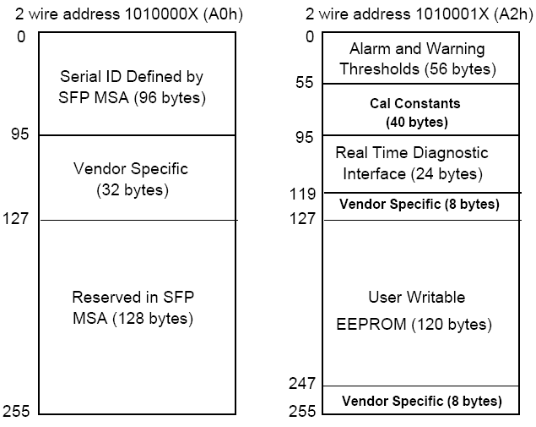

- Digital Diagnostic Monitoring Information
Parameter | Unit | Accuracy
Case Temperature | ℃ | ±3
Supply Voltage | V | ±3%
Tx Bias Current | mA | ±10%
Tx Optical Power | dB | ±3
Rx Optical Power | dB | ±3
- Recommended Interface Circuit
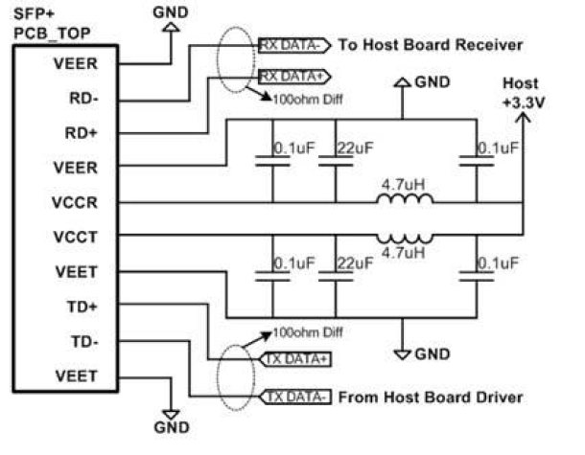
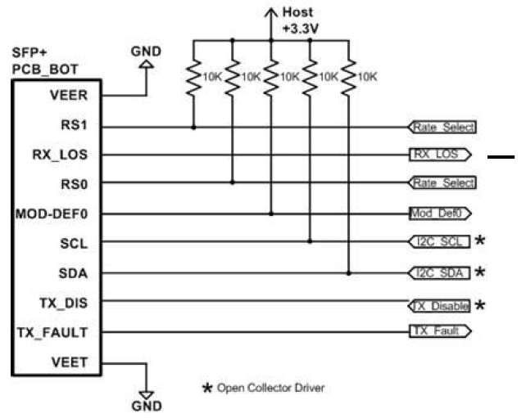
- Mechanical Dimensions
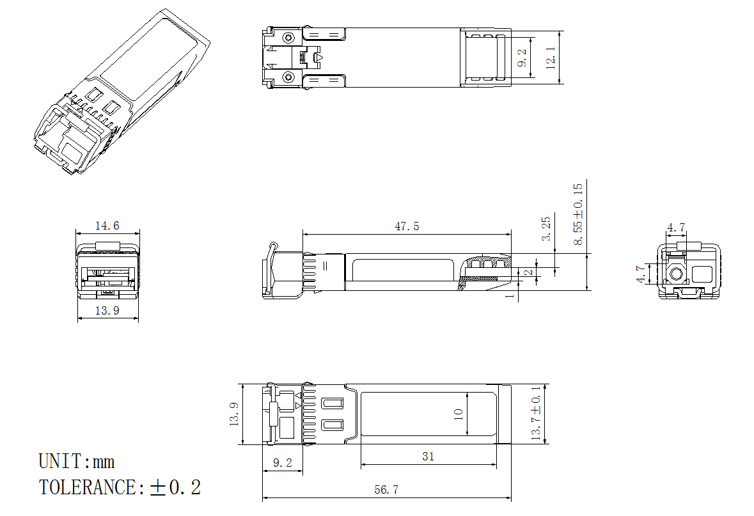
SFP wire mechanicaldrawing(Unit: mm)
Revision History
Version No. | Date | Description
1.0 | June 24, 2019 | Preliminary datasheet

