LQP40-CSR4
QSFP+40Gb/s SR4 (100~400)m DDM
PRODUCT FEATURES
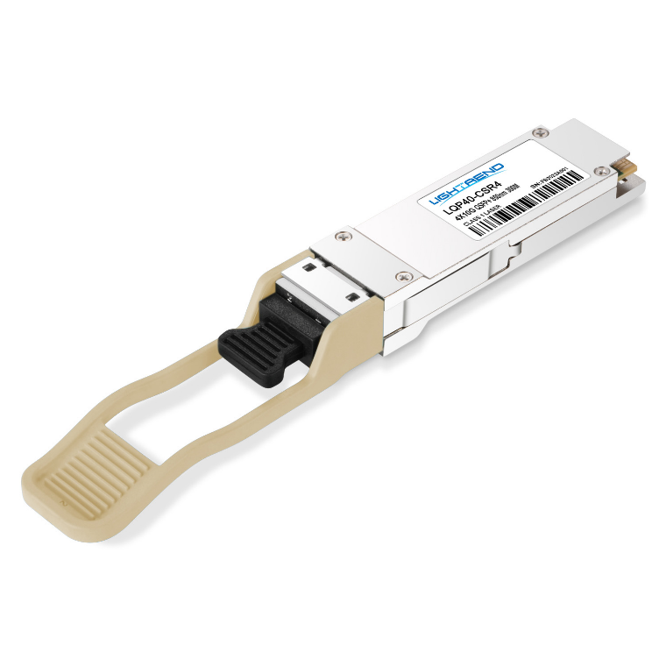
- Multi rate capability: 1.06Gb/s
to 10.5Gb/s per channel
- Reliable VCSEL array technology
- Maximum link length of 300m on OM3
Multimode Fiber(MMF) and 400m ON OM4 MMF
- Hot-pluggable QSFP+ footprint
- Single 1x12 MPO receptacle
- Maximum power dissipation<1W
- Four-channel full-duplex transceiver module
- RoHS-6 compliant and lead-free
- Support Digital Diagnostic Monitor interface
- Un retimed XLPPI electrical interface
- Case operating temperature Commercial: 0°C to +70°C
APPLICATIONS
Compliance
- QSFP+ MSA.
- IEEE802.3ba
- SFF-8436
- RoHS

- 40GBASE-SR4 40G Ethernet
- Breakout to10GBASE-SR Ethernet
- Proprietary interconnections
PRODUCT DESCRIPTION
LQP40-CSR4 are designed for use in 40 Gigabit per second links over multimode fiber. They are compliant with the QSFP+ MSA and IEEE 802.3ba 40GBASE-SR4.Module-level digital diagnostic functions are available via an I²C interface, as specified by the QSFP+ MSA. The optical transceiver is compliant per the RoHS Directive 2011/65/EU.

Ordering information
Package | Product part NO. | Data Rate(Gbps) | Media | Wavelength(nm) | TransmissionDistance(m) | Temperature Range（℃）
QSFP+ | LQP40-CSR4 | 42.0 | multi-mode fiber | 850 | 100~400 | 0~70 | Commercial
- Pin Diagram
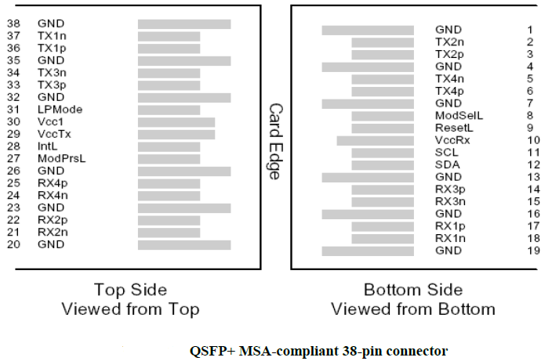
- Pin Descriptions
Pin | Symbol | Name/Description | Ref.
1 | GND | Ground | 1
2 | Tx2n | Transmitter Inverted Data Input
3 | Tx2p | Transmitter Non-Inverted Data Input
4 | GND | Ground | 1
5 | Tx4n | Transmitter Inverted Data Input
6 | Tx4p | Transmitter Non-Inverted Data Input
7 | GND | Ground | 1
8 | ModSe1L | Module Select
9 | ResetL | Module Reset
Pin | Symbol | Name/Description | Ref.
10 | Vcc Rx | +3.3V Power supply receiver
11 | SCL | 2-wire serial interface clock
12 | SDA | 2-wire serial interface data
13 | GND | Ground | 1
14 | Rx3p | Receiver Non-Inverted Data Output
15 | Rx3n | Receiver Inverted Data Output
16 | GND | Ground | 1
17 | Rx1p | Receiver Non-Inverted Data Output
18 | Rx1n | Receiver Inverted Data Output
19 | GND | Ground | 1
20 | GND | Ground | 1
21 | Rx2n | Receiver Inverted Data Output
22 | Rx2p | Receiver Non-Inverted Data Output
23 | GND | Ground | 1
24 | Rx4n | Receiver Inverted Data Output
25 | Rx4p | Receiver Non-Inverted Data Output
26 | GND | Ground | 1
27 | ModPrSL | Module Present
28 | IntL | Interrupt
29 | VccTx | +3.3V Power supply transmitter
30 | Vcc1 | +3.3V Power Supply
31 | LPMode | Low Power Mode
32 | GND | Ground | 1
33 | Tx3p | Transmitter Non-Inverted Data Input
34 | Tx3n | Transmitter Inverted Data Input
35 | GND | Ground | 1
36 | Tx1p | Transmitter Non-Inverted Data Input
37 | Tx1n | Transmitter Inverted Data Input
38 | GND | Ground | 1
Note：
1. Circuit ground is internally isolated from chassis ground.
- Absolute Maximum Ratings
Parameter | Symbol | Min. | Typ. | Max. | Unit | Ref.
Storage Temperature | T_{S} | -40 |  | 85 | ºC
Storage Ambient Relative Humidity | H_{A} | 0 |  | 85 | %
Maximum Supply Voltage | V_{CC}1,  V_{CC}T_{X},  V_{CC}R_{X} | -0.5 |  | 3.6 | V
Signal Input Voltage |  | Vcc-0.3 |  | Vcc+0.3 | V
Receiver Damage Threshold |  | +3.4 |  |  | dBm
Lead Soldering Temperature/Time | TSOLD |  |  | 260/10 | ºC/sec | 1
Lead Soldering Temperature/Time | TSOLD |  |  | 360/10 | ºC/sec | 2
Note:
1.Suitable for wave soldering.
2. Only for soldering by iron.
- General Product Characteristics
Parameter | Value | Unit | Ref.
Module Form Factor | QSFP+
Number of Lanes | 4 Tx and 4 Rx
Maximum Aggregate Data Rate | 42.0 | Gb/s
Maximum Data Rate per Lane | 10.5 | Gb/s | Higher bit rates may be supported. Please contact M-optocom
Protocols Supported | Typical applications include 40G Ethernet, Infiniband, Fibre Channel, SATA/SAS3
Management Interface | Serial,I2c-based,400kHz maximum frequency |  | As defined by the QSFP+ MSA
Data Rate Spcifications | Symbol | Min. | Typ. | Max. | Unit | Ref.
Bit Rate per Lane | BR | 1062 |  | 10500 | Mb/s | 1
Bit Error Ratiio | BER |  |  | 10⁻¹² |  | 2
Link distance on OM3 MMF | d |  |  | 300 | meters | 3
Link distance on OM4 MMF | d |  |  | 400 | meters | 3
Notes:
1. Compliant with 40G Ethernet. Compatible with 1/10 Gigabit Ethernet and 1/2/4/8/10G Fibre Channel.
2. Tested with a PRBS 2³¹-1 test pattern.
3. Per 40GBASE-SR4, IEEE 802.3ba.
- Optical Characteristics
Parameter | Symbol | Min. | Typ. | Max. | Unit | Ref.
Transmitter(per Lane)
Average Output Power | POUT | -7.6 |  | 2.4 | dBm
Transmit OMA per Lane | TxOMA | -5.6 |  | 3.0 | dBm | 1
Extinction Ratio | ER | 3.0 |  |  | dB
Center Wavelength | λC | 840 | 850 | 860 | nm
RMS Spectral Width | σ |  |  | 0.65 | nm
Transmitter and Dispersion Penalty | TDP |  |  | 3.5 | dB
Transmitter OFF Output Power | POff |  |  | -30 | dBm
Relative Intensity Noise | RIN |  |  | -128 | dB/Hz
Transmitter eye mask definition {X1,X2,X3,Y1,Y2,Y3} |  | 0.23,0.34,0.43,0.27,0.35,0.4
Receiver(per Lane)
Input Optical Wavelength | λIN | 840 | 850 | 860 | nm
Rx Sensitivity per lane | RSENS |  |  | -9.5 | dBm
InputSaturation Power (Overload) | PSAT | +2.4 |  |  | dBm
Receiver Reflectance | Rfl |  |  | -12 | dBm
Loss of Signal Assert | PA | -30 |  |  | dBm
Loss of Signal De-assert | PD |  |  | -12 | dBm
LOS Hysteresis | PD - PA | 0.5 |  | 6 | dB
Note:
1.Even if TDP is <0.9dB, the OMA min must exceed this value.
- Memory Map and Control Registers
Compatiable with SFF-8436Rev.4.8(QSFP+).
- Electrical Interface Characteristics
Parameter | Symbol | Min. | Typ. | Max. | Unit | Ref.
Supply Voltage | VCC1,  VCCTX,  VCCRX | 3.15 |  | 3.45 | V
Supply Current | ICC |  |  | 300 | mA
Transmitter(per Lane)
Input different impedance | Rin | 90 | 100 | 110 | Ω | 1
Single ended input voltage tolerance | VinT | -0.3 |  | 4.0 | V
Single ended data input swing | Vin,pp | 180 |  | 1200 | mV | 2
Receiver (per Lane)
Output different impedance | Rout | 90 | 100 | 110 | Ω | 1
Single ended data output swing | Vout,pp | 0 |  | 800 | mV | 3
Single-ended output voltage |  | -0.3 |  | 4.0 | V
Power Supply Rejection | PSR | 50 |  |  | mVpp
Note :
1.Connected directly to TX data input pins. AC coupled thereafter.
2.After internal AC coupling. Self-biasing 100Ω differential input
3.Into 100Ωdifferential termination.
- Mechanical Specifications(Unit: mm)
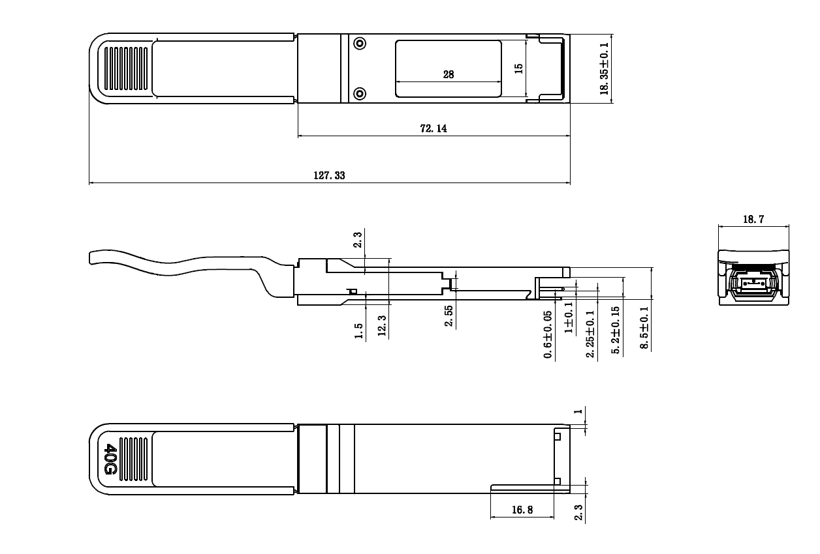
LQP40-CSR4
- Regulatory Compliance
LQP40-CSR4transeciverare RoHS-6 Compliant.
LQP40-CSR4transceiver modules are Class 1 laser eye safety compliant per IEC 60825-1, which means that they are eye safe under normal “unaided” viewing conditions. Laser radiation may be hazardous if viewed with magnifying optics.
ilight.com
Revision History
Version No. | Date | Description
1.0 | June 24, 2019 | Preliminary datasheet

