LQP40-LR4
QSFP+40Gb/s LR4 10kmWith DDM
PRODUCT FEATURES
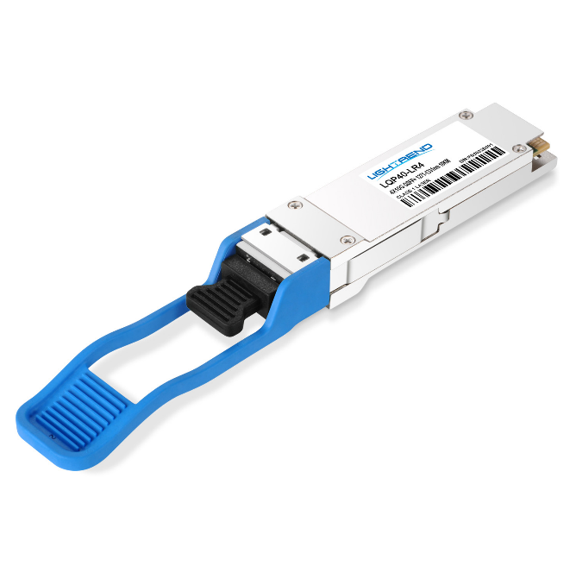
- Supports 41.2 Gb/s aggregate bitrates
- Uncooled 4x10Gb/s transmitter
- Maximum link length of 10km on Single Mode Fiber (SMF)
- Hot-pluggable QSFP+ footprint
- Duplex LC receptacles
- Power dissipation<3.5W
- RoHS-6 compliant and lead-free
- Single 3.3V power supply
- Support Digital Diagnostic Monitor interface
- Case operating temperature
Commercial: 0°C to +70°C
Compliance
- QSFP+ MSA.
- IEEE802.3ba
- SFF-8436
- RoHS

APPLICATIONS
- 40GBASE-LR4Ethernet
PRODUCT DESCRIPTION
LQP40-LR4 QSFP+ transceiver modules are designed for use in 40 Gigabit Ethernet links over single mode fiber. They are compliant with the QSFP+ MSA and IEEE 802.3ba 40GBASE-LR4.Module-level digital diagnostic functions are available via an I²C interface, as specified by the QSFP+ MSA. The optical transceiver is compliant per the RoHS Directive 2011/65/EU.

Ordering information
Package | Product part NO. | Data Rate(Gbps) | Media | Wavelength(nm) | TransmissionDistance(km) | Temperature Range（℃）
QSFP+ | LQP40-LR4 | 41.2 | single-mode fiber | 1271nm, 1291nm  1311nm, 1331nm | 10 | 0~70 | Commercial
- Pin Diagram
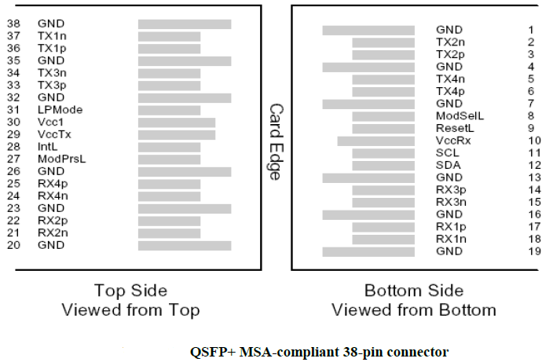
- Pin Descriptions
Pin | Symbol | Name/Description | Ref.
1 | GND | Ground | 1
2 | Tx2n | Transmitter Inverted Data Input
3 | Tx2p | Transmitter Non-Inverted Data Input
4 | GND | Ground | 1
5 | Tx4n | Transmitter Inverted Data Input
6 | Tx4p | Transmitter Non-Inverted Data Input
7 | GND | Ground | 1
8 | ModSe1L | Module Select
Pin | Symbol | Name/Description | Ref.
9 | ResetL | Module Reset
10 | Vcc Rx | +3.3V Power supply receiver
11 | SCL | 2-wire serial interface clock
12 | SDA | 2-wire serial interface data
13 | GND | Ground | 1
14 | Rx3p | Receiver Non-Inverted Data Output
15 | Rx3n | Receiver Inverted Data Output
16 | GND | Ground | 1
17 | Rx1p | Receiver Non-Inverted Data Output
18 | Rx1n | Receiver Inverted Data Output
19 | GND | Ground | 1
20 | GND | Ground | 1
21 | Rx2n | Receiver Inverted Data Output
22 | Rx2p | Receiver Non-Inverted Data Output
23 | GND | Ground | 1
24 | Rx4n | Receiver Inverted Data Output
25 | Rx4p | Receiver Non-Inverted Data Output
26 | GND | Ground | 1
27 | ModPrSL | Module Present
28 | IntL | Interrupt
29 | VccTx | +3.3V Power supply transmitter
30 | Vcc1 | +3.3V Power Supply
31 | LPMode | Low Power Mode
32 | GND | Ground | 1
33 | Tx3p | Transmitter Non-Inverted Data Input
34 | Tx3n | Transmitter Inverted Data Input
35 | GND | Ground | 1
36 | Tx1p | Transmitter Non-Inverted Data Input
37 | Tx1n | Transmitter Inverted Data Input
38 | GND | Ground | 1
Note：
1. Circuit ground is internally isolated from chassis ground.
- Absolute Maximum Ratings
Parameter | Symbol | Min. | Typ. | Max. | Unit | Ref.
Storage Temperature | T_{S} | -40 |  | 85 | ºC
Storage Ambient Relative Humidity | H_{A} | 0 |  | 85 | %
Maximum Supply Voltage | V_{CC}1,  V_{CC}T_{X},  V_{CC}R_{X} | -0.5 |  | 3.6 | V
Signal Input Voltage |  | -0.3 |  | Vcc+0.3 | V
Receiver Damage Threshold |  | +3.4 |  |  | dBm
Lead Soldering Temperature/Time | TSOLD |  |  | 260/10 | ºC/sec | 1
Lead Soldering Temperature/Time | TSOLD |  |  | 360/10 | ºC/sec | 2
Note:
1.Suitable for wave soldering.
2. Only for soldering by iron.

- General Product Characteristics
Parameter | Value | Unit | Ref.
Module Form Factor | QSFP+
Number of Lanes | 4 Tx and 4 Rx
Maximum Aggregate Data Rate | 41.2 | Gb/s
Maximum Data Rate per Lane | 10.3125 | Gb/s | Higher bit rates may be supported. Please contact Inphilight
Protocols Supported | Typical applications include 40G Ethernet
Management Interface | Serial,I2c-based,400kHz maximum frequency |  | As defined by the QSFP+ MSA

Data Rate Spcifications | Symbol | Min. | Typ. | Max. | Unit | Ref.
Bit Rate per Lane | BR |  |  | 10313 | Mb/s | 1
Bit Error Ratiio | BER |  |  | 10⁻¹² |  | 2
Link distance on SMF-28 | d |  |  | 10 | km | 3
Notes:
1. Compliant with 40GBASE-LR4 and XLPPI per IEEE 802.3ba. Compatible with 1/10 Gigabit Ethernet and 1/2/4/8/10G Fibre Channel.
2. Tested with a PRBS 2³¹-1 test pattern.
3. Per 40GBASE-LR4, IEEE 802.3ba.

- Optical Characteristics
Parameter | Symbol | Min. | Typ. | Max. | Unit | Ref.
Transmitter
Total Average Launch Power | P_{OUT} |  |  | 8.3 | dBm
Average Output Power per lane | P_{OUT} | -7 |  | 2.3 | dBm
Transmit OMA per Lane | TxOMA | -4.0 |  | 3.5 | dBm | 1
Extinction Ratio | ER | 3.5 |  |  | dB
Center Wavelength | λC | 1264.5  1284.5  1304.5  1324.5 | 1271  1291  1311  1331 | 1277.5  1297.5  1317.5  1337.5 | nm
Sidemode Suppression ratio | SMSR | 30 |  |  | dB
Transmitter and Dispersion Penalty | TDP |  |  | 3.5 | dB
Transmitter OFF Output Power | POff |  |  | -30 | dBm
Transmitter eye mask definition {X1,X2,X3,Y1,Y2,Y3} |  | 0.25,0.4,0.45,0.25,0.28,0.4
Receiver
Input Optical Wavelength | λ_{IN} | 1264.5  1284.5  1304.5  1324.5 | 1271  1291  1311  1331 | 1277.5  1297.5  1317.5  1337.5 | nm
Rx Sensitivity per lane | R_{SENS1} |  |  | -11.5 | dBm
Rx Sensitivity(OMA) | R_{SENS2} |  |  | -9.6 | dBm
InputSaturation Power (Overload) | PSAT |  |  | +3.4 | dBm
Receiver Reflectance | Rfl |  |  | -12 | dBm
Loss of Signal Assert | P_{A} | -30 |  |  | dBm
Loss of Signal De-assert | P_{D} |  |  | -12.5 | dBm
LOS Hysteresis | P_{D} - P_{A} | 0.5 |  | 6 | dB
Note:
1.Even if TDP is <0.9dB, the OMA min must exceed this value.
- Memory Map and Control Registers
Compatiable with SFF-8436Rev.4.8(QSFP+).
- Electrical Interface Characteristics
Parameter | Symbol | Min. | Typ. | Max. | Unit | Ref.
Supply Voltage | V_{CC}1,  V_{CC}T_{X},  V_{CC}R_{X} | 3.15 |  | 3.45 | V
Supply Current | I_{CC} |  |  | 1000 | mA
Transmitter
Input different impedance | R_{in} | 90 | 100 | 110 | Ω | 2
Single ended data input swing | Vin,pp | 120 |  | 820 | mV
Transmitter Disable Voltage | VDIS | 2 |  | V_{CC} | V | 3
Transmitter Enable Voltage | VEN | 0 |  | 0.8 | V
Receiver
Output different impedance | R_{out} | 90 | 100 | 110 | Ω | 2
Single ended data output swing | Vout,pp | 340 |  | 850 | mV | 4
LOS Asserted | V_{LOSA} | 2 |  | V_{CCHOST} | V | 5
LOS De-asserted | V_{LOSD} | 0 |  | 0.8 | V | 5
Power Supply Rejection | PSR | 50 |  |  | mVpp
Note :
1.Maximum total power value is specified across the full temperature and voltage range.
2.Connected directly to TX data input pins. AC coupled thereafter.
3.Or open circuit.
4.Into 100Ωdifferential termination.
5.LossOf Signal is LVTTL. Logic “0”indicates normal operation; logic “1” indicates no signal detected.
- Mechanical Specifications(Unit: mm)
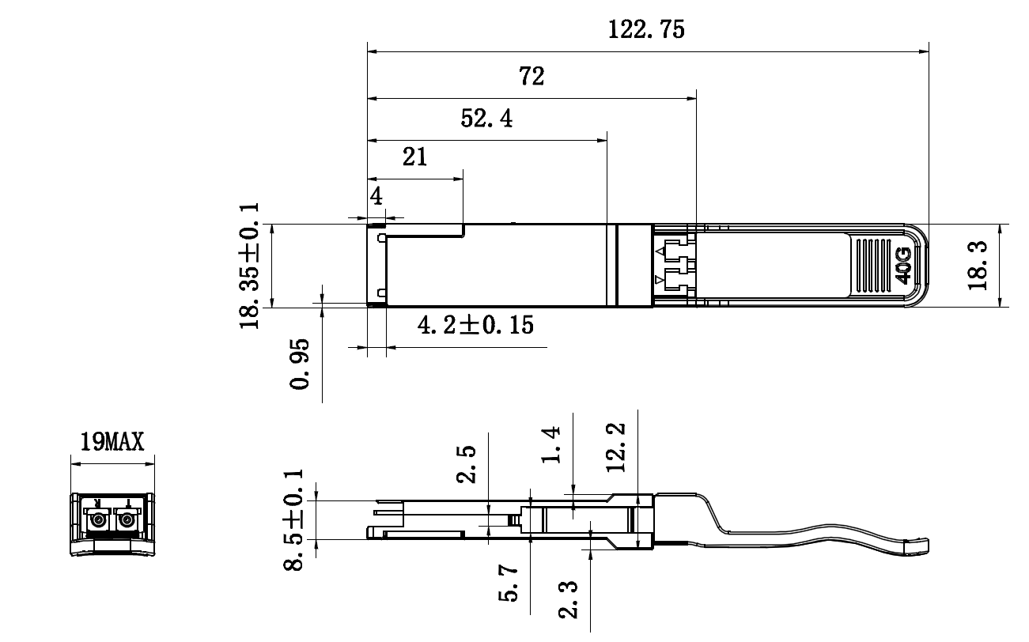
LQP40-LR4
- Regulatory Compliance
LQP40-LR4transceiverare RoHS-6 Compliant.
LQP40-LR4transceiver modules are Class 1 laser eye safety compliant per IEC 60825-1, which means that they are eye safe under normal “unaided” viewing conditions. Laser radiation may be hazardous if viewed with magnifying optics.

Revision History
Version No. | Date | Description
1.0 | June 24, 2019 | Preliminary datasheet

