LQP100-CWDM4
QSFP28 100Gb/s CWDM4 2km DDM
PRODUCT FEATURES
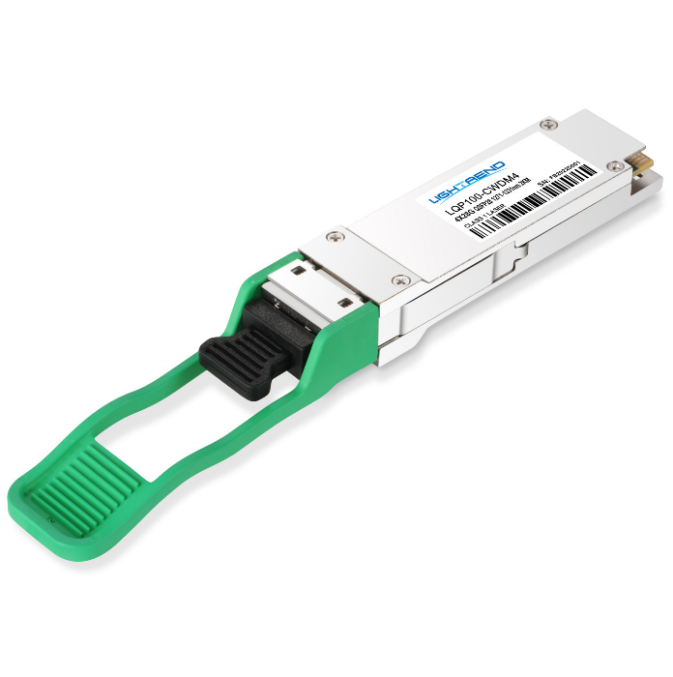
- Supports 103.1Gb/s aggregate bit rate
- 4x25Gb/s electrical interface
- 4X25Gb/s CWDM transmitter and PIN/TIA receiver
- Maximum link length of 2km on Single Mode Fiber (SMF)
- Hot-pluggable QSFP28 from factor
- Single 3.3V power supply
- Integrated 4-channel CWDM mux/Demux
for duplex LC operation
- Duplex LC receptacles
- Maximum power dissipation<3.5W
- RoHS-6 compliant and lead-free
- I²C management interface
- Case operating temperature
Commercial: 0°C to +70°C
APPLICATIONS
Compliance
- QSFP28 MSA.
- IEEE802.3bm
- SFF-8665
- RoHS

- 100 Gigabit Ethernet
PRODUCT DESCRIPTION
LQP100-CWDM4 QSFP28 transceiver modules are designed for use in 100 Gigabit Ethernet links over multimode fiber. They are compliant with the QSFP28 MSA,CWDM4 MSA and IEEE 802.3bm.Digital diagnostic functions are available via an I2C interface, as specified by the QSFP28 MSA. The optical transceiver is compliant per the RoHS Directive 2011/65/EU.

Ordering information
Package | Product part NO. | Data Rate(Gbps) | Media | Wavelength(nm) | TransmissionDistance(km) | Temperature Range（℃）
QSFP28 | LQP100-CWDM4 | 4X25 | Single-mode fiber | 1271nm  1291nm  1311nm  1331nm | 2 | 0~70 | Commercial
- Pin Diagram
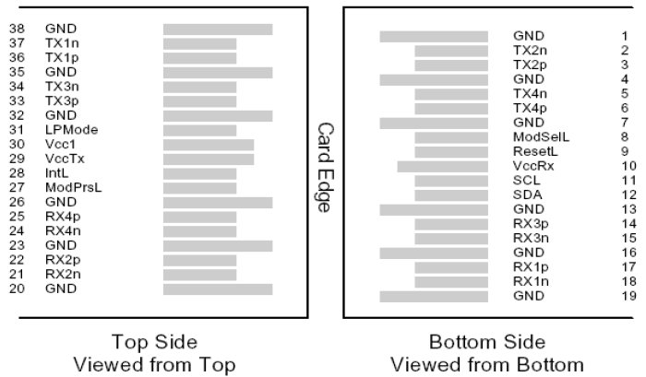

- Pin Descriptions
Pin | Symbol | Name/Description | Ref.
1 | GND | Ground | 1
2 | Tx2n | Transmitter Inverted Data Input
3 | Tx2p | Transmitter Non-Inverted Data Input
4 | GND | Ground | 1
5 | Tx4n | Transmitter Inverted Data Input
6 | Tx4p | Transmitter Non-Inverted Data Input
7 | GND | Ground | 1
8 | ModSe1L | Module Select
9 | ResetL | Module Reset
10 | Vcc Rx | +3.3V Power supply receiver
11 | SCL | 2-wire serial interface clock
12 | SDA | 2-wire serial interface data
13 | GND | Ground | 1
14 | Rx3p | Receiver Non-Inverted Data Output
15 | Rx3n | Receiver Inverted Data Output
16 | GND | Ground | 1
17 | Rx1p | Receiver Non-Inverted Data Output
18 | Rx1n | Receiver Inverted Data Output
19 | GND | Ground | 1
20 | GND | Ground | 1
21 | Rx2n | Receiver Inverted Data Output
22 | Rx2p | Receiver Non-Inverted Data Output
23 | GND | Ground | 1
24 | Rx4n | Receiver Inverted Data Output
25 | Rx4p | Receiver Non-Inverted Data Output
26 | GND | Ground | 1
27 | ModPrSL | Module Present
28 | IntL | Interrupt
29 | VccTx | +3.3V Power supply transmitter
Pin | Symbol | Name/Description | Ref.
30 | Vcc1 | +3.3V Power Supply
31 | LPMode | Low Power Mode
32 | GND | Ground | 1
33 | Tx3p | Transmitter Non-Inverted Data Input
34 | Tx3n | Transmitter Inverted Data Input
35 | GND | Ground | 1
36 | Tx1p | Transmitter Non-Inverted Data Input
37 | Tx1n | Transmitter Inverted Data Input
38 | GND | Ground | 1
Note：
1. Circuit ground is internally isolated from chassis ground.
- Absolute Maximum Ratings
Parameter | Symbol | Min. | Typ. | Max. | Unit | Ref.
Storage Temperature | T_{S} | -40 |  | 85 | ºC
Storage Ambient Relative Humidity | H_{A} | 0 |  | 85 | %
Maximum Supply Voltage | V_{CC} | -0.5 |  | 3.6 | V
Lead Soldering Temperature/Time | TSOLD |  |  | 260/10 | ºC/sec | 1
Lead Soldering Temperature/Time | TSOLD |  |  | 360/10 | ºC/sec | 2
Note:
1.Suitable for wave soldering.
2. Only for soldering by iron.
- Optical Characteristics
Parameter | Symbol | Min. | Typ. | Max. | Unit |  | Ref.
Transmitter(per lane)
Signaling Speed per Lane |  | 25.78125 ± 100 ppm |  |  | Gb/s |  | 1
Center Wavelength | λC | -- | 1264.5 – 1277.5  1284.5 – 1297.5  1304.5 – 1317.5  1324.5 – 1337.5 | -- | nm
Extinction ratio | ER | 3.5 | -- | -- | dB
Side Mode Suppression Ratio | SMSR | 30 | -- | -- | dB
Total average launch power | Ptot | -- | -- | 8.5 | dBm
Average launch power, each lane | Po | -6.5 | -- | 2.5 | dBm
OMA, each lane | OMA | -4 | -- | 2.5 | dBm |  | CW,ER>3.5dB
Difference in launch power between any  two lanes (OMA) |  |  |  | 5 | dB
TDP, each lane | TDP |  |  | 3.0 | dB |  | 2
Average launch power of OFF transmitter, each lane | Poff |  |  | -30 | dBm
Transmitter eye mask definition {X1,X2,X3,Y1,Y2,Y3} |  | {0.31, 0.40, 0.45, 0.34, 0.38, 0.4} |  |  |  |  | 3
Receiver(per lane)
Signaling Speed per Lane |  | 25.78125 ± 100 ppm |  |  | Gb/s | 4
Input Optical Wavelength | λ_{IN} |  | 1264.5 – 1277.5  1284.5 – 1297.5  1304.5 – 1317.5  1324.5 – 1337.5 |  | nm
Damage threshold |  | 3.5 |  |  | dBm
Receiver Power (OMA), each Lane |  | 2.5 |  |  | dBm
Rx Sensitivity(OMA) per lane | R_{SENS} |  |  | -10 | dBm | 5
Stressed receiver sensitivity (OMA), each lane | SRS |  |  | -7.3 | dBm | 6
Conditions of stressed receiver sensitivity test:
Vertical eye closure penalty, each lane | VECP | 1.9 |  | dB
Stressed eye J2 jitter, each lane | J2 | 0.33 |  | UI
Stressed eye J4 jitter, each lane | J4 | 0.48 |  | UI
SRS eye mask definition {X1, X2, X3, Y1, Y2, Y3} |  | {0.39, 0.50, 0.50, 0.39, 0.39, 0.4}
Loss of Signal Assert | P_{A} | -24 |  | -13.6 | dBm
Loss of Signal De-assert | P_{D} |  |  | -11.6 | dBm
LOS Hysteresis | P_{D} - P_{A} | 0.5 |  | 6 | dB
Note :
1.Transmitter consists of 4 lasers operating at 25.78Gb/s each.
2.TDP value does not include MPI penalty.
3. Hit ratio of 5x10-5, per IEEE.
4. Receiver consists of 4 photodetectors operating at 25.78Gb/s each.
5.Sensitivity is specified at 5x10-5 BER.
6.Measured with CWDM4 MSA2 conformance test signal at TP3 for 5x10-5 BER.
- Digital Diagnostic Functions
LQP100-CWDM4 QSFP28 transceivers support the I2C-based diagnostics interface specified by the QSFP28 MSA.
- Electrical Interface Characteristics
Parameter | Symbol | Min. | Typ. | Max. | Unit | Ref.
Supply Voltage | V_{CC} | 3.135 |  | 3.465 | V
Supply Current | I_{CC} |  |  | 1.12 | A
Module total power | P |  |  | 3.5 | W | 1
Transmitter
Signaling rate per lane |  | 25.78125±100ppm |  |  | Gb/s
Differential data input swing per lane | Vin,pp | 900 |  |  | mV
Differential input return loss(min) | RLd(f) | 9.5 – 0.37f, 0.01≤f<8  4.75-7.4log₁₀(f/14), 8≤f<19 |  |  | dB
Differential to common mode input return loss(min) | RLdc(f) | 22-20(f/25.78), 0.01≤f<12.89  15-6(f/25.78), 12.89≤f<19 |  |  | dB
Differential termination mismatch |  |  |  | 10 | %
Eye width |  |  | 0.46 |  | UI
Applied pk-pk sinusoidal Jitter |  | Per IEEE802.3bm Table 88-13
Eye height |  |  | 95 |  | mV
Receiver
Signaling rate per lane |  | 25.78125±100ppm |  |  | Gb/s
Differential data output swing | Vout,pp | 100 |  | 400 | mVpp | 2
 |  | 300 |  | 600
 |  | 400 | 600 | 800
 |  | 600 |  | 1200
Eye width |  | 0.57 |  |  | UI
Vertical eye closure | VEC |  |  | 5.5 | dB
Differential output return loss (min) | RLd(f) | 9.5 – 0.37f, 0.01≤f<8  4.75 – 7.4log10(f/14), 8 ≤f<19 |  |  | dB
Common to differential mode conversion return loss (min) | RLdc(f) | 22-20(f/25.78), 0.01≤f<12.89  15-6(f/25.78), 12.89≤f<19 |  |  | dB
Differential termination mismatch |  |  |  | 10 | %
Note :
1.Maximum total power value is specified across the fulltemperature and voltage range.
2.Output voltage is settable in 4 discrete range via I2C.Default range is Range 2 ( 400 – 800mV ).
- Mechanical Specifications(Unit: mm)
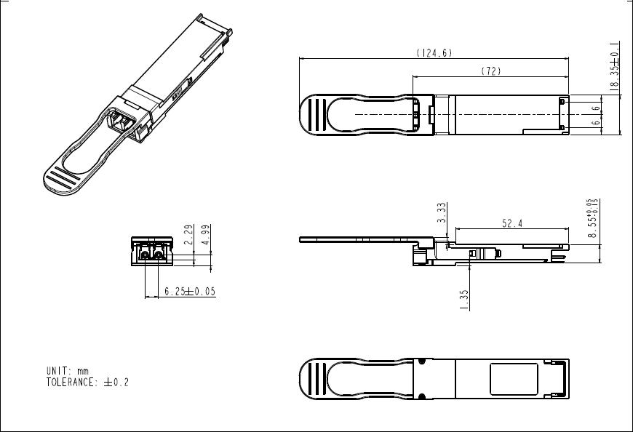
LQP100-CWDM4
- Regulatory Compliance
Item | Standard
Electromagnetic Interference (EMI) | FCC Part 15 Class B  EN55022 Class B (CISPR 22B)  VCCI Class B
Electrostatic Discharge to the Electrical Pins (ESD) | MIL-STD-883E Method 3015.7
Electrostatic Discharge to the Receptacle (ESD) | IEC 61000-4-2
RoHS | 2011/65/EU
Laser Eye Safety | FDA 21CFR 1040.10 and 1040.11
Component Recognition | UL and TUV
Revision History
Version No. | Date | Description
1.0 | June 24, 2019 | Preliminary datasheet

