LQP100-LR4
QSFP28 100Gbps LR4 10km DDM Transceiver
PRODUCT FEATURES
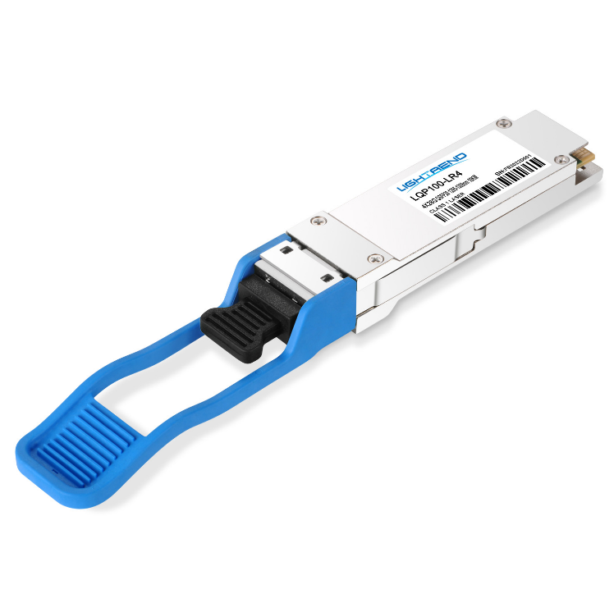
- Supports 103.1Gbps aggregate bit rate
- 4x25Gbps electrical interface
- 4X25Gbps DFBLAN-WDM
transmitter and PIN/TIA receiver
- Maximum link length of 10km on
Single Mode Fiber
- Hot pluggable QSFP28 footprint
- Duplex LC receptacles
- Single3.3V power supply
- Maximum power dissipation<4W
- RoHS-6 compliant and lead-free
- I²C management interface
- 0°C to +70°C case operating temperature
APPLICATIONS
COMPLIANCE
- QSFP28 MSA SFF-8665
- IEEE802.3ba 100GBASE-LR4
- ROHS
- 100GBASE-LR4 100G Ethernet
Ordering Information
Package | Product part NO. | Description
QSFP28 | LQP100-LR4 | 4X25Gbps,Single-mode fiber, 10Km, 0-70℃
- Pin Diagram
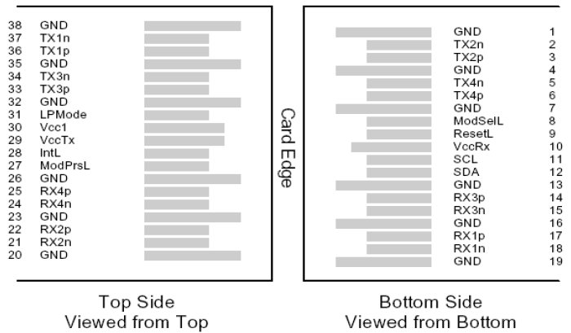
QSFP28 38pin connector (SFF 8679)
- Pin Descriptions
Pin | Symbol | Name/Description | Note
1 | GND | Ground | 1
2 | Tx2n | Transmitter Inverted Data Input
3 | Tx2p | Transmitter Non-Inverted Data Input
4 | GND | Ground | 1
5 | Tx4n | Transmitter Inverted Data Input
6 | Tx4p | Transmitter Non-Inverted Data Input
7 | GND | Ground | 1
8 | ModSe1L | Module Select
9 | ResetL | Module Reset
10 | Vcc Rx | +3.3V Power supply receiver
11 | SCL | 2-wire serial interface clock
Pin | Symbol | Name/Description | Note
12 | SDA | 2-wire serial interface data
13 | GND | Ground | 1
14 | Rx3p | Receiver Non-Inverted Data Output
15 | Rx3n | Receiver Inverted Data Output
16 | GND | Ground | 1
17 | Rx1p | Receiver Non-Inverted Data Output
18 | Rx1n | Receiver Inverted Data Output
19 | GND | Ground | 1
20 | GND | Ground | 1
21 | Rx2n | Receiver Inverted Data Output
22 | Rx2p | Receiver Non-Inverted Data Output
23 | GND | Ground | 1
24 | Rx4n | Receiver Inverted Data Output
25 | Rx4p | Receiver Non-Inverted Data Output
26 | GND | Ground | 1
27 | ModPrSL | Module Present
28 | IntL | Interrupt
29 | VccTx | +3.3V Power supply transmitter
30 | Vcc1 | +3.3V Power Supply
31 | LPMode | Low Power Mode
32 | GND | Ground | 1
33 | Tx3p | Transmitter Non-Inverted Data Input
34 | Tx3n | Transmitter Inverted Data Input
35 | GND | Ground | 1
36 | Tx1p | Transmitter Non-Inverted Data Input
37 | Tx1n | Transmitter Inverted Data Input
38 | GND | Ground | 1
Note：
1. Circuit ground is internally isolated from chassis ground.
- Absolute Maximum Ratings
Parameter | Symbol | Min. | Typ. | Max. | Unit | Remark
Storage Temperature | T_{S} | -40 |  | 85 | ºC
Storage Ambient Relative Humidity | H_{A} | 0 |  | 85 | %
Case Operation Temperature | ℃ | 0 |  | 70 | ºC
Maximum Supply Voltage | V_{CC} | -0.5 |  | 4.0 | V
Signal Input Voltage |  | -0.3 |  | Vcc+0.3 | V
Receiver Damage Threshold |  | +5.5 |  |  | dBm
- Optical Characteristics
Parameter | Symbol | Min. | Typ. |  | Max. | Unit | Remark
Transmitter
Total Average Output Power | P_{OUT} |  |  |  | 10.5 | dBm
Average Output Power, each lane |  | -4.3 |  |  | 4.5 | dBm
Optical Modulation Amplitude (OMA), each lane |  | -1.3 |  |  | 4.5 | dBm
Extinction Ratio | ER | 4 |  |  |  | dB
Center Wavelength | λc | 1294.53  1299.02  1303.54  1308.09 |  | 1295.56  1300.05  1304.58  1309.14 | 1296.59  1301.09  1305.63  1310.19 | nm
Spectral Width |  |  |  |  | 1 | nm
Transmitter OFF Output Power | POff |  |  |  | -30 | dBm
Transmitter eye mask definition {X1,X2,X3,Y1,Y2,Y3} |  | {0.25,0.4,0.45,0.25,0.28,0.4} |  |  |  |  | Hit ratio 5x10⁻⁵
Receiver
Input Optical Wavelength | λ_{IN} | 1294.53  1299.02  1303.54  1308.09 |  | 1295.56  1300.05  1304.58  1309.14 | 1296.59  1301.09  1305.63  1310.19 | nm
Average receive power, each lane |  | -10.6 |  |  | 4.5 |  | BER = 10–12
Receive power, each lane (OMA) |  | -8.6 |  |  | 4.5 | dBm | BER = 10–12
Receiver Reflectance | Rfl |  |  |  | -26 | dBm
Loss of Signal Assert | P_{A} | -24 |  |  | -13.6 | dBm
Loss of Signal De-assert | P_{D} |  |  |  | -11.6 | dBm
LOS Hysteresis | P_{D}- P_{A} | 0.5 |  |  | 6 | dB
- Electrical Interface Characteristics
Parameter | Symbol | Min. | Typ. | Max. | Unit | Remark
Supply Voltage | V_{CC} | 3.135 |  | 3.465 | V
Supply Current | I_{CC} |  |  | 1.15 | A
Module total power | P |  |  | 4 | W
Transmitter
Signaling rate per lane |  | 25.78125±100ppm |  |  | Gbps
Differential pk-pk input voltage | Vin,pp,diff | 350 |  |  | mV
Differential input Resistance | Rtin |  | 100 |  | Ohm
Receiver
Signaling rate per lane |  | 25.78125±100ppm |  |  | Gbps
Differential data output swing | Vout,pp |  | 400 |  | mVpp
Eye width |  | 0.57 |  |  | UI
Differential output Resistance |  |  | 100 |  | ohm
- Digital Diagnostic Functions
LQP100-LR4 transceivers support the I2C-based diagnostics interface specified by the SFF8636.
- Mechanical Specifications(Unit: mm)
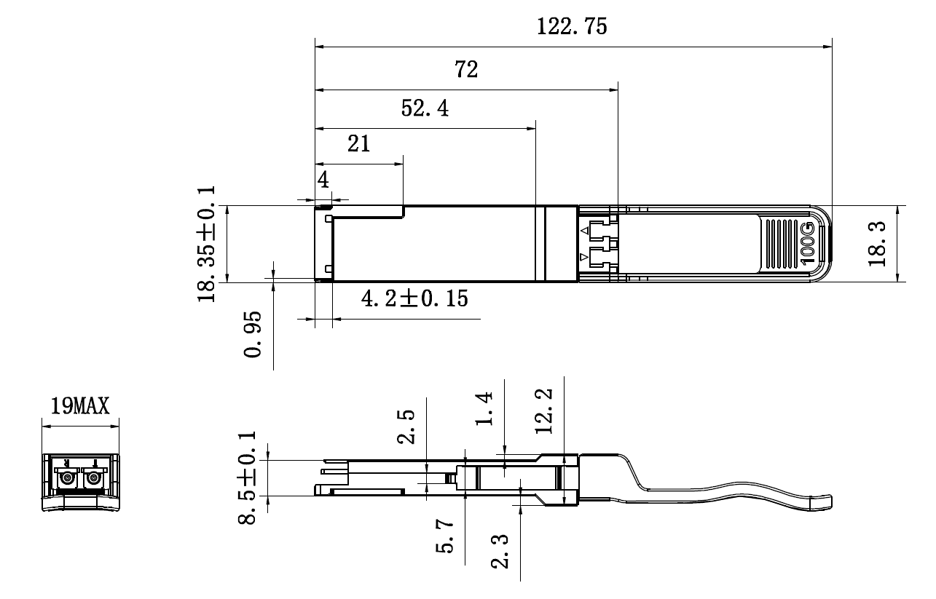
Revision History
Version No. | Date | Description
1.0 | June 24, 2019 | Preliminary datasheet

