LQP100-SR4
QSFP28100Gb/s SR4 100m DDM
PRODUCT FEATURES
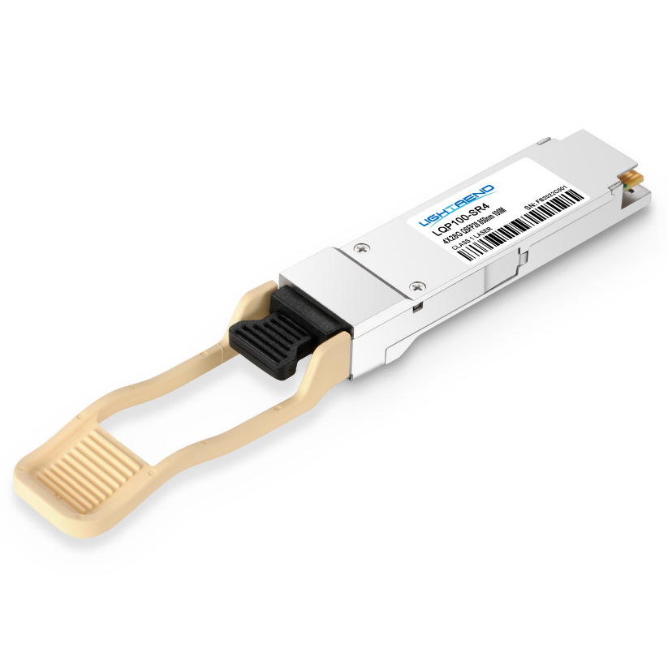
- Supports 103.1Gb/s aggregate bit rate
- 4x25Gb/s electrical interface
- Maximum link length of 100m on
OM4 Multimode Fiber (MMF)
- Hot-pluggable QSFP28 footprint
- Single MPO 12 receptacle
- Maximum power dissipation<3.5W
- RoHS-6 compliant and lead-free
- Support Digital Diagnostic Monitor interface
- Case operating temperature
Commercial: 0°C to +70°C
APPLICATIONS
Compliance
- QSFP28 MSA.
- IEEE802.3bm
- SFF-8436
- RoHS

- 100GBASE-SR4 100G Ethernet
PRODUCT DESCRIPTION
LQP100-SR4 are designed for use in 100 Gigabit Ethernet links over multimode fiber. They are compliant with the QSFP28 MSA and IEEE 802.3bm 100GBASE-SR4and CAUI-4. Module-level digital diagnostic functions are available via an I2C interface, as specified by the QSFP+ MSA. The optical transceiver is compliant per the RoHS Directive 2011/65/EU.

Ordering information
Package | Product part NO. | Data Rate(Gbps) | Media | Wavelength(nm) | TransmissionDistance(m) | Temperature Range（℃）
QSFP28 | LQP100-SR4 | 4X25 | multi-mode fiber | 850 | 100 | 0~70 | Commercial
- Pin Diagram
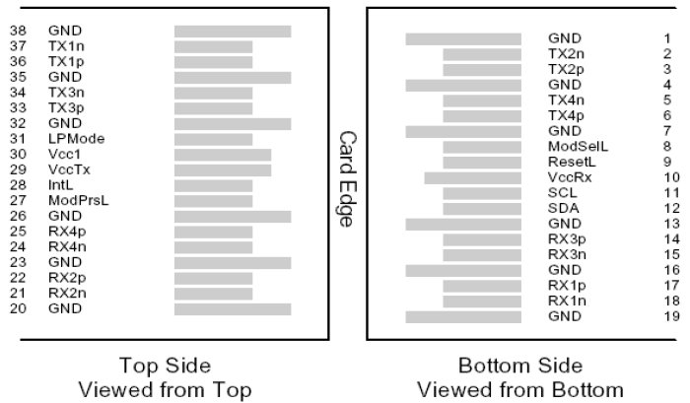
- Pin Descriptions
Pin | Symbol | Name/Description | Ref.
1 | GND | Ground | 1
2 | Tx2n | Transmitter Inverted Data Input
3 | Tx2p | Transmitter Non-Inverted Data Input
4 | GND | Ground | 1
5 | Tx4n | Transmitter Inverted Data Input
6 | Tx4p | Transmitter Non-Inverted Data Input
7 | GND | Ground | 1
8 | ModSe1L | Module Select
Pin | Symbol | Name/Description | Ref.
9 | ResetL | Module Reset
10 | Vcc Rx | +3.3V Power supply receiver
11 | SCL | 2-wire serial interface clock
12 | SDA | 2-wire serial interface data
13 | GND | Ground | 1
14 | Rx3p | Receiver Non-Inverted Data Output
15 | Rx3n | Receiver Inverted Data Output
16 | GND | Ground | 1
17 | Rx1p | Receiver Non-Inverted Data Output
18 | Rx1n | Receiver Inverted Data Output
19 | GND | Ground | 1
20 | GND | Ground | 1
21 | Rx2n | Receiver Inverted Data Output
22 | Rx2p | Receiver Non-Inverted Data Output
23 | GND | Ground | 1
24 | Rx4n | Receiver Inverted Data Output
25 | Rx4p | Receiver Non-Inverted Data Output
26 | GND | Ground | 1
27 | ModPrSL | Module Present
28 | IntL | Interrupt
29 | VccTx | +3.3V Power supply transmitter
30 | Vcc1 | +3.3V Power Supply
31 | LPMode | Low Power Mode
32 | GND | Ground | 1
33 | Tx3p | Transmitter Non-Inverted Data Input
34 | Tx3n | Transmitter Inverted Data Input
35 | GND | Ground | 1
36 | Tx1p | Transmitter Non-Inverted Data Input
37 | Tx1n | Transmitter Inverted Data Input
38 | GND | Ground | 1
Note：
1. Circuit ground is internally isolated from chassis ground.
- Absolute Maximum Ratings
Parameter | Symbol | Min. | Typ. | Max. | Unit | Ref.
Storage Temperature | T_{S} | -40 |  | 85 | ºC
Storage Ambient Relative Humidity | H_{A} | 0 |  | 85 | %
Maximum Supply Voltage | V_{CC} | -0.5 |  | 4.0 | V
Signal Input Voltage |  | -0.3 |  | Vcc+0.3 | V
Receiver Damage Threshold |  | +3.4 |  |  | dBm
Lead Soldering Temperature/Time | TSOLD |  |  | 260/10 | ºC/sec | 1
Lead Soldering Temperature/Time | TSOLD |  |  | 360/10 | ºC/sec | 2
Note:
1.Suitable for wave soldering.
2. Only for soldering by iron.
- General Product Characteristics
Data Rate Spcifications | Symbol | Min. | Typ. | Max. | Unit | Ref.
Bit Rate(all wavelength combined) | BR |  |  | 103.1 | Gb/s | 1
Bit Error Ratio(pre-FEC) | BER |  |  | 10⁻⁵ |  | 2
Maximum Supported Distance
Fiber Type
Link distance on OM3 MMF | d |  |  | 70 | meters | 3
Link distance on OM4 MMF | d |  |  | 100 | meters | 3
Notes:
1.Supports 100GBASE-SR4 per IEEE 802.3bm.
2. Tested with a PRBS 2³¹-1 test pattern.
3. Requires FEC on the host to support maximum distance, per 100GBASE-SR4.
- Optical Characteristics
Parameter | Symbol | Min. | Typ. | Max. | Unit | Ref.
Transmitter(per lane)
Average Output Power per lane | P_{OUT} | -8.4 |  | 2.4 | dBm
Transmit OMA per Lane | TxOMA | -6.4 |  | 3.0 | dBm
Extinction Ratio | ER | 2 |  |  | dB
Center Wavelength | λC | 840 |  | 860 | nm
RMS Spectral Width | σ |  |  | 0.6 | nm
Transmitter OFF Output Power | POff |  |  | -30 | dBm
Transmitter eye mask definition {X1,X2,X3,Y1,Y2,Y3} |  | {0.3,0.38,0.45,0.35,0.41,0.5} |  |  |  | 1
Receiver(per lane)
Input Optical Wavelength | λ_{IN} | 840 |  | 860 | nm
Rx Sensitivity(OMA) per lane | R_{SENS} |  |  | -10.3 | dBm | 2
InputSaturation Power (Overload) | PSAT | +3.4 |  |  | dBm
Receiver Reflectance | Rfl |  |  | -12 | dBm
Loss of Signal Assert | P_{A} | -30 |  |  | dBm
Loss of Signal De-assert | P_{D} |  |  | -11.3 | dBm
LOS Hysteresis | P_{D} - P_{A} | 0.5 |  | 6 | dB
Note:
1.Hit Ratio 1.5x10-3 hit/sample.
2.Minimum value is informative only and not the principal indicator of signal strength.
- Digital Diagnostic Functions
LQP100-SR4 QSFP28 transceivers support the I2C-based diagnostics interface specified by the QSFP28 MSA.
- Electrical Interface Characteristics
Parameter | Symbol | Min. | Typ. | Max. | Unit | Ref.
Supply Voltage | V_{CC} | 3.15 |  | 3.45 | V
Supply Current | I_{CC} |  |  | 1.5 | A
Module total power | P |  |  | 3.5 | W | 1
Transmitter
Signaling rate per lane |  | 25.78125±100ppm |  |  | Gb/s
Differential pk-pk input voltage tolerance | Vin,pp,diff |  |  | 900 | mV
Single-ended voltage tolerance | Vin,pp | -0.35 |  | +3.3 | V
Module stress input test |  | Per Section 83E.3.4.1,IEEE802.3bm
Receiver
Signaling rate per lane |  | 25.78125±100ppm |  |  | Gb/s
Differential data output swing | Vout,pp | 100 |  | 400 | mVpp | 2
 |  | 300 |  | 600
 |  | 400 | 600 | 800
 |  | 600 |  | 1200
Eye width |  | 0.57 |  |  | UI
Eye height,differential |  | 228 |  |  | mV
Vertical eye closure | VEC | 5.5 |  |  | dB
Note :
1.Maximum total power value is specified across the fulltemperature and voltage range.
when CDRs are locked or a lack of input signal results in squelch being activated.If incorrect frequencies cause the CDRs to continuously attempt to lock, maximum power dissipation may reach 4.5W.
2.Output voltage is settable in 4 discrete range via I2C.Default range is Range 2 ( 400 – 800mV ).
- Mechanical Specifications(Unit: mm)
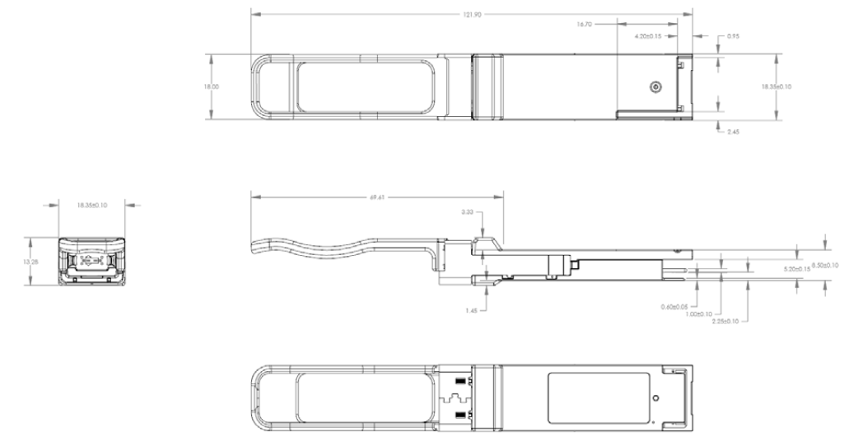LQP100-SR4
Revision History
Version No. | Date | Description
1.0 | June 24, 2019 | Preliminary datasheet

