LQD400-SR8

QSFP-DD 400Gb/s SR8 100m DDM

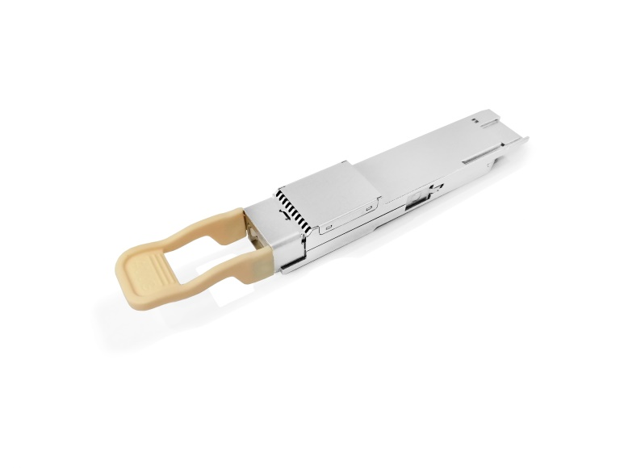**PRODUCT FEATURES**

* Hot pluggable QSFP-DD form factor
* Supports 400Gb/s aggregate bit rate
* Up to 53.125Gbps data rate per channel
* Maximum link length of 70m on

OM3 and 100m on OM4

* Power dissipation: <10W
* PAM4 Modulation
* Commercial: 0°C to +70°C

**APPLICATIONS**

**Compliance**

* QSFP-DD MSA.
* IEEE802.3cd
* RoHS
* 400GBASE-SR8 400G Ethernet
* Data Center

**PRODUCT DESCRIPTION**

LQD400-SR8 is a QSFP-DD optical transceiver for 400G links over multimode fiber. It is compliant with the QSFP-DD MSA specifications. It operates at 53.125Gbps per lane up to 70m over OM3 and 100m OM4 Multi-mode fiber.

**Ordering information**

|  |  |  |  |  |  |  |  |
| --- | --- | --- | --- | --- | --- | --- | --- |
| **Package** | **Product part NO.** | **Data Rate(Gbps)** | **Media** | **Wavelength(nm)** | **Transmission Distance(m)** | **Temperature Range（℃）** | |
| QSFP-DD | LQD400-SR8 | 8X53.125 | Multi-mode fiber | 850 | 70(OM3)  100(OM4) | 0~70 | Commercial |

**Pin Diagram**

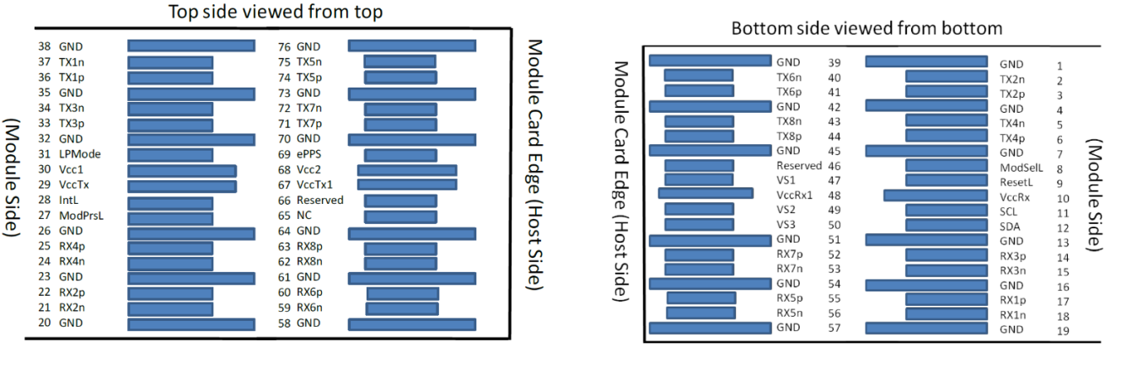

1. **Pin Descriptions**

|  |  |  |  |
| --- | --- | --- | --- |
| **Pad** | **Symbol** | **Description** | **Notes** |
| 1 | GND | Ground |  |
| 2 | Tx2n | Transmitter Inverted Data Input |  |
| 3 | Tx2p | Transmitter Non-Inverted Data Input |  |
| 4 | GND | Ground |  |
| 5 | Tx4n | Transmitter Inverted Data Input |  |
| 6 | Tx4p | Transmitter Non-Inverted Data Input |  |
| 7 | GND | Ground |  |
| 8 | ModSelL | Module Select |  |
| 9 | ResetL | Module Reset |  |
| 10 | VccRx | +3.3V Power Supply Receiver |  |
| 11 | SCL | 2-wire serial interface clock |  |
| 12 | SDA | 2-wire serial interface data |  |
| 13 | GND | Ground |  |
| 14 | Rx3p | Receiver Non-Inverted Data Output |  |
| 15 | Rx3n | Receiver Inverted Data Output |  |
| 16 | GND | Ground |  |
| 17 | Rx1p | Receiver Non-Inverted Data Output |  |
| 18 | Rx1n | Receiver Inverted Data Output |  |
| 19 | GND | Ground |  |
| 20 | GND | Ground |  |
| 21 | Rx2n | Receiver Inverted Data Output |  |
| 22 | Rx2p | Receiver Non-Inverted Data Output |  |
| 23 | GND | Ground |  |
| 24 | Rx4n | Receiver Inverted Data Output |  |
| 25 | Rx4p | Receiver Non-Inverted Data Output |  |
| 26 | GND | Ground |  |
| 27 | ModPrsL | Module Present |  |
| 28 | IntL | Interrupt |  |
| 29 | VccTx | +3.3V Power supply transmitter |  |
| 30 | Vcc1 | +3.3V Power supply |  |
| 31 | LPMode | Low Power mode; |  |
| 32 | GND | Ground |  |
| 33 | Tx3p | Transmitter Non-Inverted Data Input |  |
| 34 | Tx3n | Transmitter Inverted Data Input |  |
| 35 | GND | Ground |  |
| 36 | Tx1p | Transmitter Non-Inverted Data Input |  |
| 37 | Tx1n | Transmitter Inverted Data Input |  |
| 38 | GND | Ground |  |
| 39 | GND | Ground |  |
| 40 | Tx6n | Transmitter Inverted Data Input |  |
| 41 | Tx6p | Transmitter Non-Inverted Data Input |  |
| 42 | GND | Ground |  |
| 43 | Tx8n | Transmitter Inverted Data Input |  |
| 44 | Tx8p | Transmitter Non-Inverted Data Input |  |
| 45 | GND | Ground |  |
| 46 | Reserved | For future use |  |
| 47 | VS1 | Module Vendor Specific 1 |  |
| 48 | VccRx1 | 3.3V Power Supply |  |
| 49 | VS2 | Module Vendor Specific 2 |  |
| 50 | VS3 | Module Vendor Specific 3 |  |
| 51 | GND | Ground |  |
| 52 | Rx7p | Receiver Non-Inverted Data Output |  |
| 53 | Rx7n | Receiver Inverted Data Output |  |
| 54 | GND | Ground |  |
| **Pad** | **Symbol** | **Description** | **Notes** |
| 55 | Rx5p | Receiver Non-Inverted Data Output |  |
| 56 | Rx5n | Receiver Inverted Data Output |  |
| 57 | GND | Ground |  |
| 58 | GND | Ground |  |
| 59 | Rx6n | Receiver Inverted Data Output |  |
| 60 | Rx6p | Receiver Non-Inverted Data Output |  |
| 61 | GND | Ground |  |
| 62 | Rx8n | Receiver Inverted Data Output |  |
| 63 | Rx8p | Receiver Non-Inverted Data Output |  |
| 64 | GND | Ground |  |
| 65 | NC | No Connect |  |
| 66 | Reserved | For future use |  |
| 67 | VccTx1 | 3.3V Power Supply |  |
| 68 | Vcc2 | 3.3V Power Supply |  |
| 69 | Reserved | For future use |  |
| 70 | GND | Ground |  |
| 71 | Tx7p | Transmitter Non-Inverted Data Input |  |
| 72 | Tx7n | Transmitter Inverted Data Input |  |
| 73 | GND | Ground |  |
| 74 | Tx5p | Transmitter Non-Inverted Data Input |  |
| 75 | Tx5n | Transmitter Inverted Data Input |  |
| 76 | GND | Ground |  |

1. **Absolute Maximum Ratings**

|  |  |  |  |  |  |  |
| --- | --- | --- | --- | --- | --- | --- |
| **Parameter** | **Symbol** | **Min.** | **Typ.** | **Max.** | **Unit** | **Ref.** |
| Storage Temperature | TS | -40 |  | 85 | ºC |  |
| Storage Ambient Relative Humidity | HA | 0 |  | 85 | % |  |
| Maximum Supply Voltage | VCC | -0.5 |  | 3.6 | V |  |
| Lead Soldering Temperature/Time | TSOLD |  |  | 260/10 | ºC/sec | 1 |
| Lead Soldering Temperature/Time | TSOLD |  |  | 360/10 | ºC/sec | 2 |

Note:

1.Suitable for wave soldering.

2. Only for soldering by iron.

1. **Electrical Characteristics**

|  |  |  |  |  |  |  |
| --- | --- | --- | --- | --- | --- | --- |
| **Parameter** | **Symbol** | **Min.** | **Typ.** | **Max.** | **Unit** | **Ref.** |
| Supply Voltage | Vcc | 3.135 | 3.3 | 3.465 | V |  |
| Transmitter | | | | | | |
| Input Differential impedace | Rin |  | 100 |  | Ω |  |
| Differential Data Input Swing | Vin,pp | 400 |  | 900 | mV |  |
| Receiver | | | | | | |
| Differential data output swing | Vout,pp |  |  | 900 | mV |  |

1. **Optical Characteristics**

|  |  |  |  |  |  |  |  |
| --- | --- | --- | --- | --- | --- | --- | --- |
| **Parameter** | **Symbol** | **Min.** | **Typ.** | **Max.** | **Unit** | | **Ref.** |
| **Transmitter(per lane)** | | | | | | | |
| Signaling Speed per Lane |  | 26.5625±100ppm | | | GBd | |  |
| Center Wavelength | λC | 840 | 850 | 860 | nm | |  |
| RMS Spectral Width | Δλ |  |  | 0.6 | nm | |  |
| Extinction ratio | ER | 3 | -- | -- | dB | |  |
| Average launch power, each lane | Po | -6 | -- | 4 | dBm | |  |
| OMA, each lane | OMA | -4 | -- | 3 | dBm | |  |
| Transmitter and dispersion eye closure(TDECQ), each lane(max) | TDECQ |  |  | 4.9 | dB | | 2 |
| Average launch power of OFF transmitter, each lane | Poff |  |  | -30 | dBm | |  |
| **Receiver(per lane)** | | | | | | | |
| Signaling Speed per Lane |  | 26.5625± 100 ppm | | | Gb/s |  | |
| Damage threshold |  | 5 |  |  | dBm |  | |
| Average receive power, each lane |  | -7.9 |  | 4 |  |  | |
| Unstressed receive sensitivity, each lane | RSENS |  |  | -7 | dBm | 1 | |
| Loss of Signal Assert | PA | -30 |  |  | dBm |  | |
| Loss of Signal De-assert | PD |  |  | -7.5 | dBm |  | |
| LOS Hysteresis | PD - PA | 0.5 |  | 6 | dB |  | |

Note :1.Measured where BER=2.4E-4 with a PRBS31Q @26.5625GBaund.

1. **Digital Diagnostic Functions**

LQD400-SR8 QSFP-DD transceivers support the I2C-based diagnostics interface specified by the QSFPDD MSA.

1. **Mechanical Specifications**(Unit: mm)



LQD400-SR8

1. **Regulatory Compliance**

|  |  |
| --- | --- |
| **Item** | **Standard** |
| Electromagnetic Interference (EMI) | FCC Part 15 Class B  EN55022 Class B (CISPR 22B)  VCCI Class B |
| Electrostatic Discharge to the Electrical Pins (ESD) | MIL-STD-883E Method 3015.7 |
| Electrostatic Discharge to the Receptacle (ESD) | IEC 61000-4-2 |
| RoHS | 2011/65/EU |
| Laser Eye Safety | FDA 21CFR 1040.10 and 1040.11 |
| Component Recognition | UL and TUV |

**Revision History**

|  |  |  |
| --- | --- | --- |
| **Version No.** | **Date** | **Description** |
| 1.0 | June 16, 2020 | Preliminary datasheet |